

SOFTWARE ARCHITECTURE AND DESIGN
Course Project Report

Record of Changes
Date | A*  M, D | In charge | Change Description
*A - Added M - Modified D - Delete
I. Project Overview

1.1. Project Information
- English name: Cinema Management System
- Vietnamese name: Hệ thống quản lý rạp chiếu phim
- Team name: SE1919 NJ - Team 6
- Software type: Web

1.2. Project Team
StudentID | Full Name | Role | Email
HE186417 | Kiều Đức Mạnh | Leader | manhkdhe186417@fpt.edu.vn
HE186415 | Nguyễn Thị Hằng | Member | hangnthe186415@fpt.edu.vn
HS180005 | Phạm Yến Nhi | Member | nhipyhs180005@fpt.edu.vn
HE190009 | Đỗ Xuân Tài | Member | taidoyasuovn@gmail.com
HE186379 | Trần Đăng Dũng | Member | dungtdhe186379@fpt.edu.vn

1.3. Product Background
Currently, many cinemas in Hanoi operate independently and use different systems for managing movie schedules, ticket sales, and seat reservations. Although online booking platforms already exist, the management of multiple cinemas is still fragmented and lacks centralized control.
To address this issue, a web-based Cinema Management System is proposed. The system aims to provide a unified platform for managing cinemas in Hanoi, including movie scheduling, seat management, ticket booking, and revenue tracking, thereby improving operational efficiency and management effectiveness.

1.4. Major Features
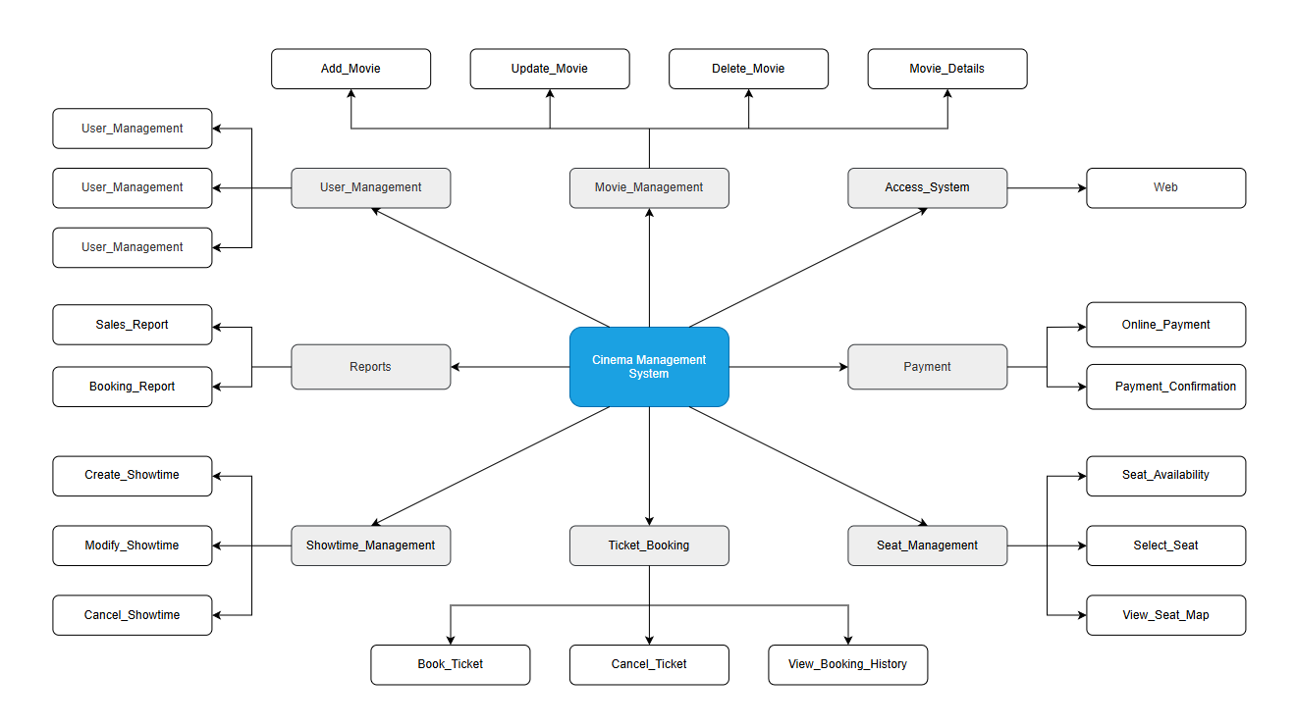
FE-01: Order and pay for movie tickets online or at the cinema counter.
FE-02: Select movies, showtimes, and seats before confirming a booking.
FE-03: Create, view, modify, and cancel ticket bookings.
FE-04: Create, view, modify, delete, and archive movie and showtime information.
FE-05: View movie details including description, duration, genre, and trailer.
FE-06: Manage screening rooms and seat layouts.
FE-07: Process payments and generate electronic tickets.
FE-08: View booking history and sales reports.

1.5. Tools & Infrastructures

Category | Tools / Infrastructure
Technology | ReactJS, HTML, CSS, JavaScript, Axios, React Router DOM(FrontEnd), Node.js, Express.js (BackEnd)
Database | MySQL server
API | Restful API
IDEs/Editors | Visual Studio Code, Visual Studio
Diagramming | DrawIO
Documentation | Google Docs/Sheets/Slides
Version Control | Git
Deployment server | Azure
Test tool | Thunder Client, Swagger
Project management | GitLab (Tasks, Defects), Excel, Jira

II. Software Requirement Specification

1. Overall Requirement

1.1 Context Diagram
The Cinema Management System is a software system developed to improve the management of movies, showtimes, and ticket booking processes in a cinema. The system allows guests and customers to view movie information, showtimes, ticket prices, and seat availability, as well as to book and pay for tickets online. The context diagram below illustrates the external entities and system interfaces for release 1.0. The system is expected to evolve over several releases, ultimately the system to support additional online payment, loyalty programs to enhance customer experience and operational efficiency.
./66777x76x6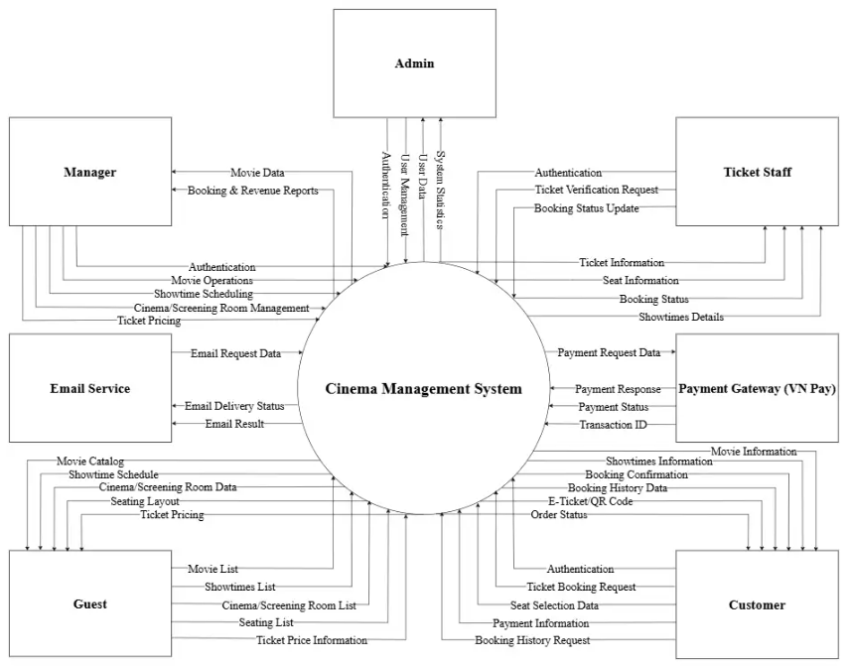

1.2 Main Business Workflows

1.2.1 Order Processing
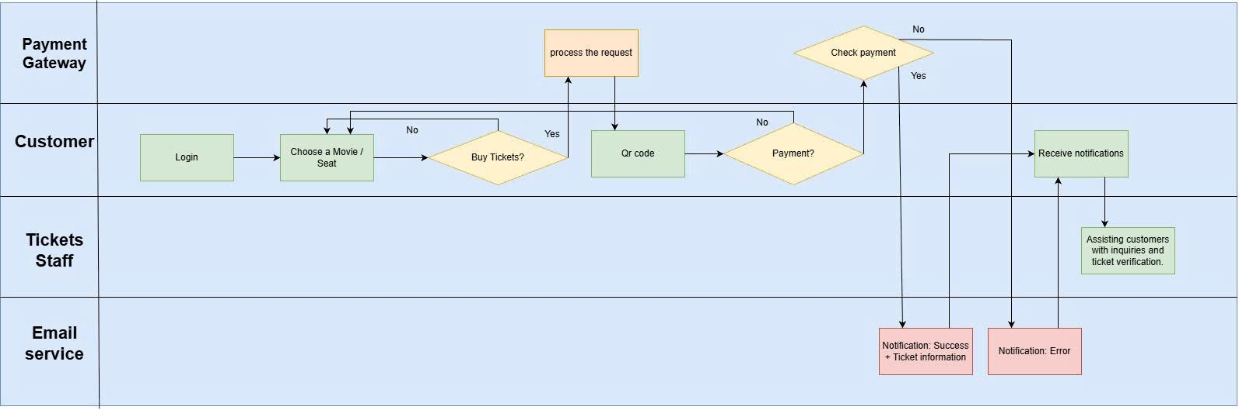
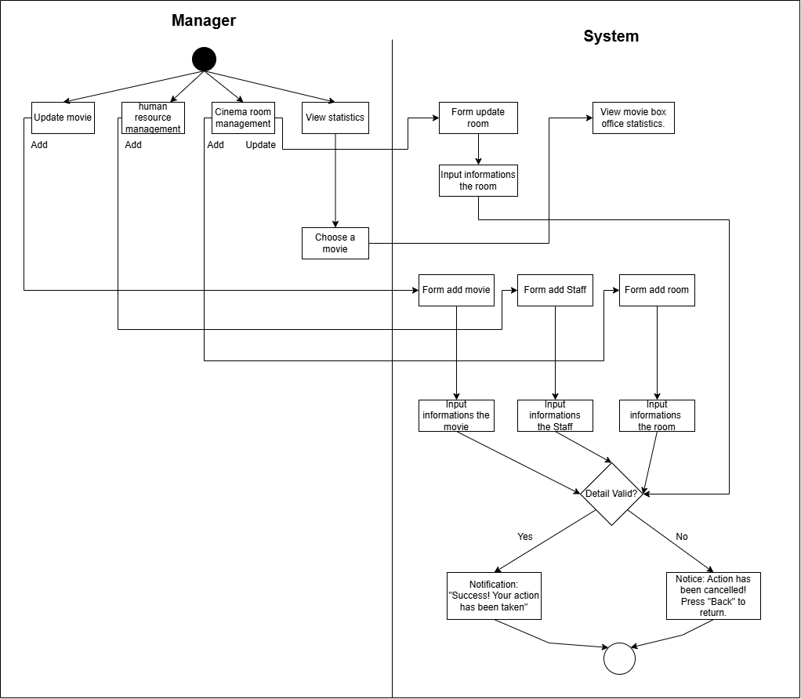..

1.3. User Requirements

1.3.1 Actors

# | Actor | Description
1 | Admin | The Admin is responsible for administering and maintaining the entire Cinema Management System. This actor handles authentication, user and role management, system configuration, and monitors overall system status to ensure security, consistency, and stable operation.
2 | Manager | The Manager interacts with the system to manage core cinema business data, including movies, showtimes, screening rooms, and ticket pricing. The Manager also accesses booking and revenue reports to support operational monitoring, performance analysis, and business decision-making.
3 | Ticket Staff | Ticket Staff use the system to perform ticketing operations at the cinema counter. Their responsibilities include user authentication, submitting ticket verification requests, updating booking status, and retrieving ticket details, seat information, showtime details, and booking status to assist customers during ticket purchase and validation processes.
4 | Customer | The Customer is a registered user who interacts with the Cinema Management System to book movie tickets online. Customers can authenticate themselves, browse movie and showtime information, select seats, submit ticket booking requests, make payments through the integrated payment gateway, and view their booking history and order status.
5 | Guest | The Guest is an unregistered user who can access the system without authentication. Guests are allowed to view movie lists, showtime schedules, screening room information, seating availability, and ticket pricing. However, to proceed with ticket booking and payment, the Guest must register or log in to become a Customer.

1.3.2 Use Case List (UC)

ID | Use Case | Feature | Use Case Description
01 | Login | Manager | The Manager logs into the cinema management system in order to access movie management, showtime management, and reporting functions.
02 | Configure Movie for Screening | Manager | The Manager configures movie information so that the movie can be scheduled for screening and displayed to customers.
03 | Schedule Movie Showtime | Manager | The Manager schedules showtimes for a movie by assigning a cinema room and screening time so that tickets can be sold.
04 | View Ticket Information | Ticket Staff | The Ticket Staff views ticket details to assist customers or prepare for ticket verification.
05 | Ticket Verification Request | Ticket Staff | The Ticket Staff verifies a customer’s ticket before allowing entry to the cinema.
06 | Booking Status Update | Ticket Staff | The Ticket Staff updates the booking status after successful ticket verification
07 | View Showtime and Seat Information | Ticket Staff | The Ticket Staff views showtime details and seat availability to support customer inquiries.
08 | View Movie List | Guest | The Guest views the list of available movies in the system.
09 | View Movie Detail | Guest | The Guest views detailed information of a selected movie.
10 | Manage Users | Admin | The Admin manages user accounts, including viewing the user list and performing create, update, or delete operations on user accounts.
11 | View User List | Admin | Admin views the list of all users registered in the Cinema Management System.
12 | Book movie ticket | Customer | This use case describes the process in which a customer books a movie ticket through the Cinema Management System, including selecting a movie, choosing a showtime, selecting seats, making a payment, and receiving an electronic ticket (QR Code).
13 | View Booking History | Customer | This use case describes how a customer views their ticket booking history, including information about previously booked movies, showtimes, seats, booking status, and electronic tickets.

1.3.3 Use Case Diagrams

1.3.3.1 UCs for Manager
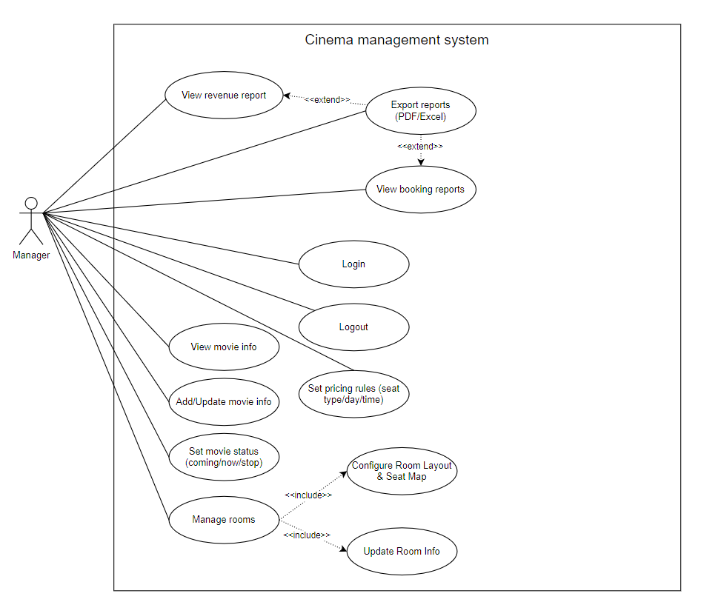

1.3.3.2 UCs for Ticket Staff

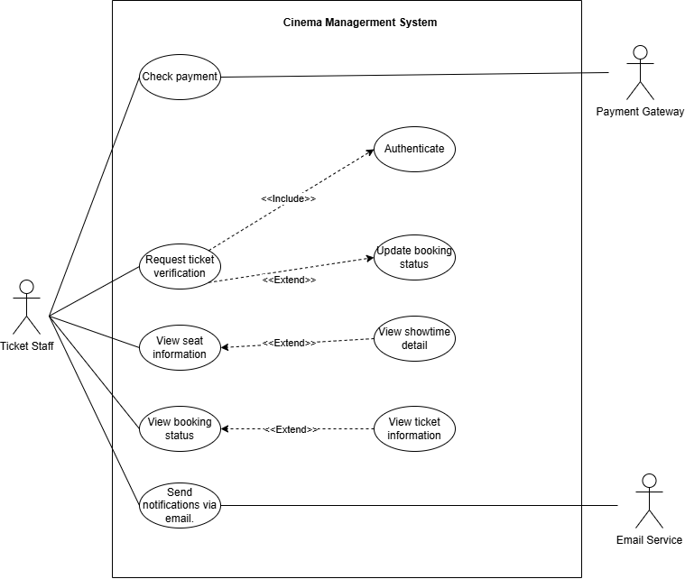

1.3.3.3 UCs for Guest
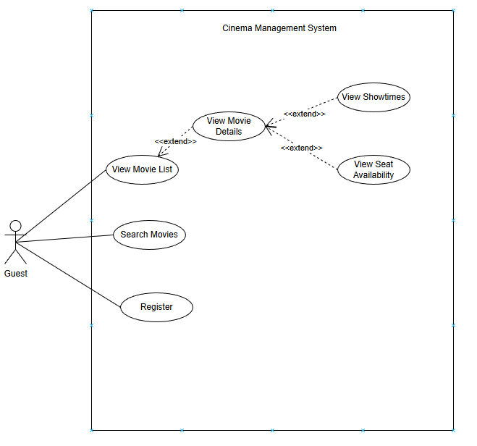

1.3.3.4 UCs for Admin
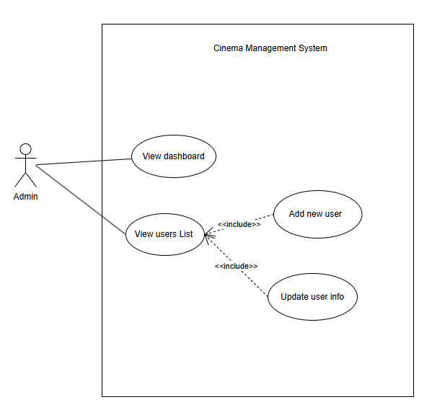

1.3.3.5 UCs for Customer

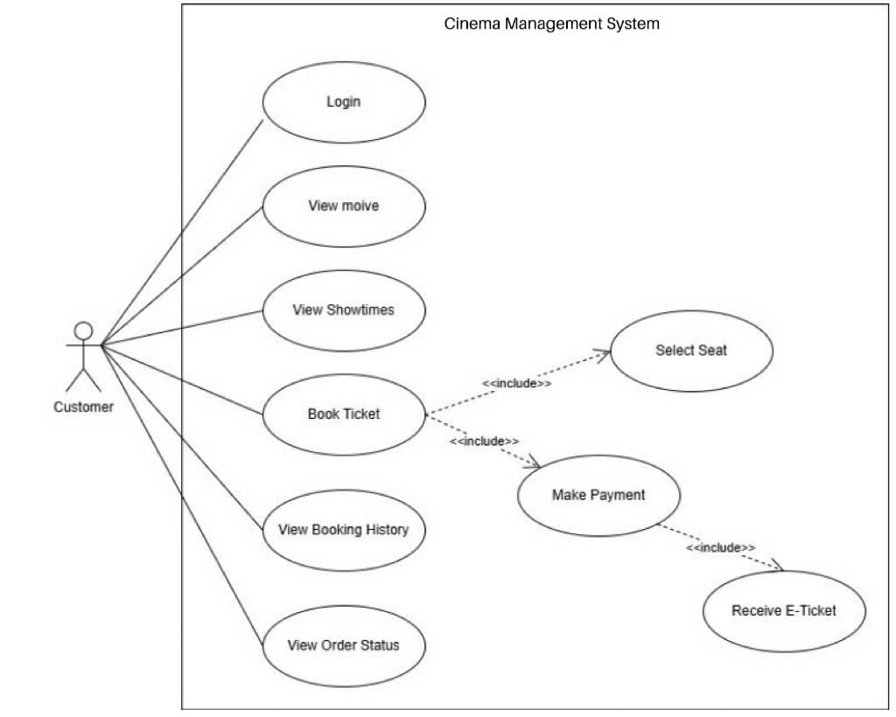

2. System Functionalities

2.1 Screens Flow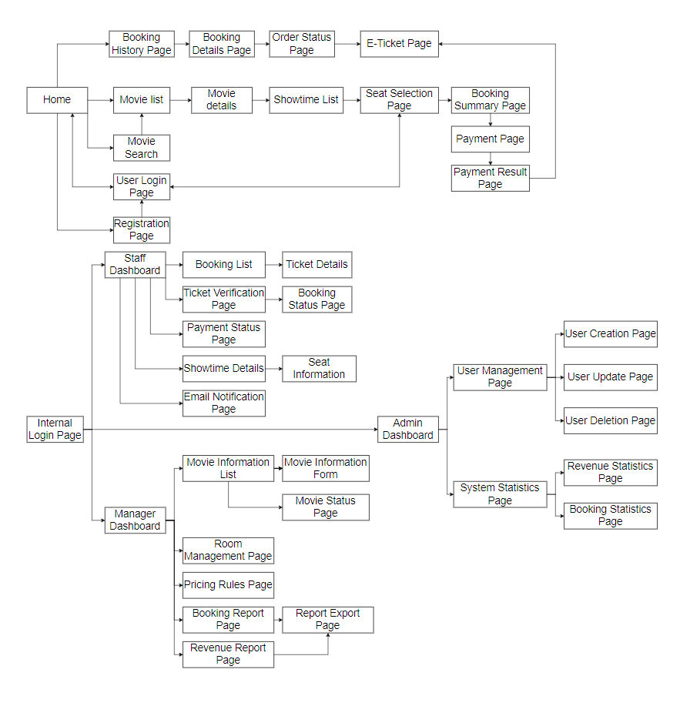

2.2 Screen Authorization
Screen | Guest | Customer | Ticket Staff | Manager | Admin
Home Page | X | X | X | X | X
Movie List | X | X | X | X | X
Movie Details | X | X | X | X | X
Showtime List | X | X | X | X | X
Seat Selection Page | X | X | X | X | X
Movie Search | X | X | X | X | X
Login Page |  | X | X | X | X
Logout Page |  | X | X | X | X
Register Page | X
Booking Summary Page |  | X
Payment Page |  | X
Payment Result Page |  | X
E-Ticket Page |  | X
Booking History Page |  | X
Booking Details Page |  | X
Order Status Page |  | X
Customer Profile Page |  | X
Staff Dashboard |  |  | X
Booking List |  |  | X
Ticket Details |  |  | X
Ticket Verification Page |  |  | X
Booking Status Page |  |  | X
Showtime Details |  |  | X
Seat Information |  |  | X
Payment Status Page |  |  | X
Email Notification Page |  |  | X
Manager Dashboard |  |  |  | X
Movie Information List |  |  |  | X
Movie Information Form |  |  |  | X
Movie Status Page |  |  |  | X
Room Management Page |  |  |  | X
Pricing Rules Page |  |  |  | X
Booking Report Page |  |  |  | X
Revenue Report Page |  |  |  | X
Report Export Page |  |  |  | X
Admin Dashboard |  |  |  |  | X
User Management Page |  |  |  |  | X
User Creation Page |  |  |  |  | X
User Update Page |  |  |  |  | X
User Deletion Page |  |  |  |  | X
System Statistics Page |  |  |  |  | X
Revenue Statistics Page |  |  |  |  | X
Booking Statistics Page |  |  |  |  | X

2.3 Non-UI Functions
# | Feature | System Function | Description
1 | Authentication | User Authentication Service | Validates user credentials, determines user roles, and establishes authenticated sessions for the system.
2 | Authorization | Role Authorization Service | Controls access to system features and screens based on authenticated user roles.
3 | Booking Management | Booking Processing Service | Handles creation, update, and status management of ticket bookings within the system.
4 | Ticket Verification | Ticket Validation Service | Verifies ticket validity based on booking status, showtime, and usage history.
5 | Payment Integration | Payment Gateway Integration Service | Communicates with external payment gateways to verify payment status and transaction results.
6 | Notification | Email Notification Service | Sends system-generated email notifications such as booking confirmations and ticket verification results.
7 | Scheduling | Showtime Scheduling Service | Manages movie showtime scheduling logic and prevents conflicts in rooms and time slots.
8 | Pricing | Pricing Calculation Service | Calculates ticket prices based on seat type, date, time, and configured pricing rules.
9 | Booking Reporting | Booking Report Generation Service | Aggregates booking data to generate booking-related statistics and reports.
10 | Revenue Reporting | Revenue Report Generation Service | Calculates revenue data and generates revenue statistics for management purposes.
11 | Export | Report Export Service | Exports system reports to external file formats such as PDF and Excel.
12 | Data Validation | Input Validation Service | Performs server-side validation for critical system data to ensure data consistency and integrity.
13 | Audit | System Audit Logging Service | Records critical system events and user actions for monitoring and audit purposes.
14 | Data Maintenance | Booking Expiration Job | Automatically updates or cancels expired unpaid bookings based on system-defined time limits.
15 | System Maintenance | Scheduled Data Cleanup Job | Periodically removes obsolete or temporary data to maintain system performance.
16 | User Management | User Account Management Service | Handles creation, update, activation, deactivation, and deletion of user accounts.

2.4 Entity Relationship Diagram

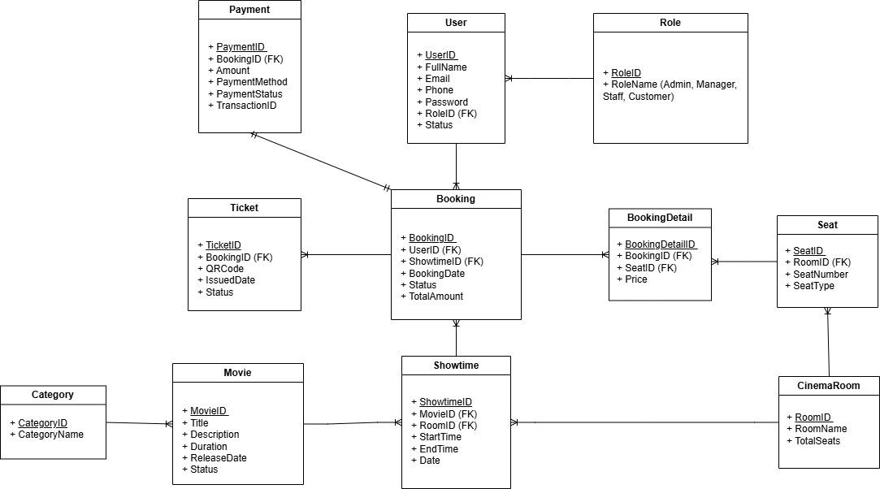
Entities Description
# | Entity | Description
1 | User | Stores user information including customers, admins, managers, and ticket staff
2 | Role | Defines user roles such as Admin, Manager, Ticket Staff, and Customer
3 | Movie | Stores information about movies being shown in the cinema
4 | Showtime | Represents the screening schedule of a movie at a specific time and room
5 | Cinema | Stores cinema branch information
6 | ScreeningRoom | Stores information about screening rooms within a cinema
7 | Seat | Represents seating layout and seat information in screening rooms
8 | Ticket | Stores ticket details for each seat and showtime
9 | Booking | Stores ticket booking information made by users
10 | Payment | Stores payment transaction information via VNPay
11 | TicketPrice | Defines ticket pricing based on seat type or time

3. Use Case Specifications

3.1 Manager

3.1.1 UC01 – Login
ID and Name | UC01 – Login
Created by | Đỗ Xuân Tài
Primary Actor | Manager | Secondary Actor | None
Description | The Manager logs into the cinema management system in order to access movie management, showtime management, and reporting functions.
Preconditions | The Manager has a valid account in the system.  The system is available.
Main Sequence | - The Manager enters a username and password.  - The system validates the login credentials.  - If the credentials are valid, the system creates an authenticated session.  - The system displays the management dashboard to the Manager.
Alternative Sequences | Step 2: If the username or password is incorrect, the system displays an error message and requests re-entry.  Step 3: If the account is inactive or locked, the system denies access and notifies the Manager.
Post conditions | The Manager is successfully authenticated and can access management features.
Business Rule | Only users with the Manager role are allowed to access management functions.

3.1.2 UC02 – Configure Movie for Screening
ID and Name | UC02 – Configure Movie for Screening
Created by | Đỗ Xuân Tài
Primary Actor | Manager | Secondary Actor | None
Description | The Manager configures movie information so that the movie can be scheduled for screening and displayed to customers.
Preconditions | The Manager is authenticated.  The movie exists in the system or the Manager has permission to add a new movie.
Main Sequence | - The Manager accesses the Movie Management function.  - The Manager selects an existing movie or creates a new movie entry.  - The Manager enters or updates movie details (title, duration, age rating, language, description).  - The Manager sets the movie status (Coming Soon / Now Showing / Stopped).  - The system validates the information.  - The system saves the movie configuration.
Alternative Sequences | Step 3: If required information is missing or invalid, the system displays an error message and requests correction.  Step 6: If the system fails to save the data, an error message is shown and the operation is cancelled.
Post conditions | The movie is configured and available for showtime scheduling.
Business Rule | Only movies with valid duration and age rating can be configured for screening.

3.1.3 UC03 – Configure Room Layout & Seat Map
ID and Name | UC03 – Configure Room Layout & Seat Map
Created by | Đỗ Xuân Tài
Primary Actor | Manager | Secondary Actor | None
Description | The Manager configures the cinema room layout and seat map (rows/columns, seat positions, seat types, and seat availability) so the system can sell tickets and assign seats correctly for showtimes.
Preconditions | The Manager is authenticated.  The room exists in the system, or the Manager has permission to create a new room.
Main Sequence | - The Manager accesses the Room Management function.  - The Manager selects a room or creates a new room.  - The Manager defines the room layout (screen position, rows/columns, aisles/sections).  - The Manager generates seats or manually adds seats with labels (e.g., A1, A2…).  - The Manager assigns seat attributes (type: Standard/VIP/Couple/Accessible; status: Active/Blocked).  - The system validates the layout and seat data (unique seat codes, valid positions, capacity rules).  - The Manager saves the configuration.  - The system stores the seat map and makes it available for showtime scheduling and ticket booking.
Alternative Sequences | Step 3–5: If layout/seat data is invalid (duplicate seat code, missing row/seat label, out-of-range position), the system shows an error and requests correction.  Step 7–8: If saving fails, the system shows an error message and the operation is cancelled.  (Optional) Step 4: If the Manager chooses “Auto-generate seat map”, the system generates seats based on rows/columns and templates.
Post conditions | The room layout and seat map are configured and can be used for showtime setup and customer seat selection.
Business Rule | Seat codes must be unique within a room.  A room must have at least one active seat to be available for scheduling.  Seats marked as Blocked cannot be sold.

3.1.4 UC04 – Schedule Movie Showtime
ID and Name | UC04 – Schedule Movie Showtime
Created by | Đỗ Xuân Tài
Primary Actor | Manager | Secondary Actor | None
Description | The Manager schedules showtimes for a movie by assigning a cinema room and screening time so that tickets can be sold.
Preconditions | The Manager is authenticated.  The movie has been configured for screening.  Cinema rooms exist in the system.
Main Sequence | - The Manager accesses the Showtime Management function.  - The Manager selects a movie.  - The Manager selects a cinema room, screening date, and start time.  - The system checks for schedule conflicts.  - If no conflict exists, the system creates the showtime.  - The system displays the newly created showtime.
Alternative Sequences | Step 4: If a conflict is detected, the system notifies the Manager and requests a different room or time.  Step 5: If saving fails, the system displays an error message.
Post conditions | A valid showtime is created and available for ticket booking.
Business Rule | A cinema room cannot have overlapping showtimes.

3.2 Ticket Staff

3.2.1 UC05 - View Ticket information
ID and Name | UC05 – View Ticket Information
Created by | Kiều Đức Mạnh
Primary Actor | Ticket Staff | Secondary Actor | None
Description | The Ticket Staff views ticket details to assist customers or prepare for ticket verification.
Preconditions | The Ticket Staff is authenticated.  The ticket exists in the system.
Main Sequence | - The Ticket Staff accesses the ticket search function.  - The Ticket Staff enters a ticket code or scans a QR code.  - The system retrieves ticket details.  - The system displays ticket information.
Alternative Sequences | Step 3: If the ticket is not found, the system displays a notification.
Post conditions | Ticket information is successfully displayed.
Business Rule | Each ticket must have a unique ticket code.

3.2.2 UC06 - Ticket Verification Request
ID and Name | UC06 – Ticket Verification Request
Created by | Kiều Đức Mạnh
Primary Actor | Ticket Staff | Secondary Actor | None
Description | The Ticket Staff verifies a customer’s ticket before allowing entry to the cinema.
Preconditions | The Ticket Staff is authenticated.  Ticket information is available.
Main Sequence | - The Ticket Staff selects the ticket verification function.  - The Ticket Staff scans the ticket QR code or enters the ticket code.  - The system checks ticket validity and usage status.  - The system confirms the ticket is valid.
Alternative Sequences | Step 3: If the ticket is invalid or already used, the system displays a warning message.
Post conditions | The ticket verification result is recorded.
Business Rule | A ticket can only be verified once.

3.2.3 UC07 - Booking Status Update
ID and Name | UC07 – Booking Status Update
Created by | Kiều Đức Mạnh
Primary Actor | Ticket Staff | Secondary Actor | None
Description | The Ticket Staff updates the booking status after successful ticket verification.
Preconditions | The Ticket Staff is authenticated.  The ticket has been verified successfully.
Main Sequence | - The system prompts for a booking status update.  - The Ticket Staff confirms the status change.  - The system updates the booking status to “Checked-in”  - The system saves the updated status.
Alternative Sequences | Step 3: If the update fails, the system displays an error message.
Post conditions | The booking status is updated correctly.
Business Rule | Only verified tickets can have their booking status updated.

3.2.4 UC08 - View Showtime and Seat Information
ID and Name | UC08 – View Showtime and Seat Information
Created by | Kiều Đức Mạnh
Primary Actor | Ticket Staff | Secondary Actor | None
Description | The Ticket Staff views showtime details and seat availability to support customer inquiries.
Preconditions | The Ticket Staff is authenticated.  Showtime data exists in the system.
Main Sequence | - The Ticket Staff selects a movie showtime.  - The system displays showtime details.  - The Ticket Staff requests seat information.  - The system displays seat availability.
Alternative Sequences | Step 1: If no showtime exists, the system displays a notification.
Post conditions | Showtime and seat information is displayed.
Business Rule | Seat availability must reflect real-time booking status.

3.3 Guest

3.3.1 UC09 – View Movie List
ID and Name | UC09 – View Movie List
Created by | Nguyễn Thị Hằng
Primary Actor | Guest | Secondary Actor
Description | The Guest views the list of available movies in the system.
Preconditions | The system is running. Movie data exists.
Main Sequence | - Guest accesses the system.  - Guest selects the movie list.  - System displays available movies.
Alternative Sequences | If no movies are available, the system displays a notification.
Post conditions | The movie list is displayed.
Business Rule | Movies must be active to appear in the list.

3.3.2 UC10 – View Movie Detail
ID and Name | UC10 – View Movie Detail
Created by | Nguyễn Thị Hằng
Primary Actor | Guest | Secondary Actor
Description | The Guest views detailed information of a selected movie.
Preconditions | Movies list is displayed.
Main Sequence | - Guest selects a movie.  - System shows movie details.
Alternative Sequences | If movie data is unavailable, the system shows an error message.
Post conditions | Movie details are displayed.
Business Rule | Movie details must be retrieved from the database.

3.4 Admin

3.4.1 UC11 – Manage Users
ID and Name | UC11 – Manage Users
Created by | Phạm Yến Nhi
Primary Actor | Admin | Secondary Actor | None
Description | The Admin manages user accounts, including viewing the user list and performing create, update, or delete operations on user accounts.
Preconditions | Admin has successfully logged into the system.
Main Sequence | - Admin selects the Manage Users function.  - The system displays the list of existing users.  - Admin chooses a user management action (create, update, delete).  - The system performs the selected action and updates the user data.  - The system displays the updated user list to the admin.
Alternative Sequences | Step 3a: Admin selects Create User → system displays create user form.  Step 3b: Admin selects Update User → system displays update user form.  Step 3c: Admin selects Delete User → system asks for confirmation before deleting.
Post conditions | User data is created, updated, or deleted successfully in the system.
Business Rule | Only Admin is allowed to manage user accounts. Usernames must be unique.

3.4.2 UC12 – View User List
ID and Name | UC12 – View User List
Created by | Phạm Yến Nhi
Primary Actor | Admin | Secondary Actor | None
Description | Admin views the list of all users registered in the Cinema Management System.
Preconditions | Admin has successfully logged into the system.
Main Sequence | 1. Admin requests to view the user list.  2. The system retrieves user data from the database.  3. The system displays the user list, including basic information such as user ID, name, role and status.
Alternative Sequences | Step 2: If no users exist, the system displays an empty list message.
Post conditions | The user list is successfully displayed to the admin.
Business Rule | User information must be displayed according to access control policies.

3.5 Customer

3.5.1 UC13 - Book Movie Ticket
ID and Name | UC13 – Book movie ticket
Created by | Trần Đăng Dũng
Primary Actor | Customer | Secondary Actor | Payment Gateway (VN Pay)
Description | This use case describes the process in which a customer books a movie ticket through the Cinema Management System, including selecting a movie, choosing a showtime, selecting seats, making a payment, and receiving an electronic ticket (QR Code).
Preconditions | -The customer has a valid registered account  -The customer has successfully logged into the system  -The selected movie showtime has available seats
Main Sequence | - The customer selects a movie  - The system displays the available showtimes for the selected movie  - The customer selects a showtime  - The system displays the seating layout for the selected showtime  - The customer selects one or more seats  - The customer confirms the ticket booking request  - The system sends a payment request to the payment gateway  - The payment gateway processes the payment  - The system receives a successful payment response  - The system generates an electronic ticket (QR Code)  - The system sends the booking confirmation and e-ticket to the customer
Alternative Sequences | A1: Payment Failed  - The payment gateway returns a payment failure response  - The system notifies the customer of the payment failure  - The customer may retry the payment or cancel the booking  A2: Seat Unavailable  - The selected seat becomes unavailable during the booking process  - The system notifies the customer  - The customer selects another available seat
Post conditions | The booking information is successfully stored in the system  The selected seats are marked as occupied  The electronic ticket (QR Code) is generated and delivered to the customer
Business Rule | A booking is confirmed only after successful payment  A seat cannot be booked by more than one customer for the same showtime  Payment must be completed within a specified time limit

3.5.2 UC14 - View Booking History
ID and Name | UC14 – View Booking History
Created by | Trần Đăng Dũng
Primary Actor | Customer | Secondary Actor | None
Description | This use case describes how a customer views their ticket booking history, including information about previously booked movies, showtimes, seats, booking status, and electronic tickets.
Preconditions | The customer has a valid registered account  The customer has successfully logged into the system
Main Sequence | 1. The customer selects the View Booking History function  2. The system retrieves the customer’s booking history data  3. The system displays a list of previous bookings  4. The customer selects a specific booking to view details  5. The system displays detailed booking information, including movie, showtime, seat, and booking status
Alternative Sequences | A1: No Booking History Available  - The system determines that the customer has no previous bookings  - The system displays a message indicating that no booking history is available  A2: System Error  - The system fails to retrieve booking history data  - The system displays an error message and requests the customer to try again later
Post conditions | The customer’s booking history is successfully displayed  No system data is modified
Business Rule | Only authenticated customers can view their booking history  A customer can view only their own booking history  Booking history data must be displayed in chronological order

4. Non-Functional Requirements

4.1 External Interfaces
User Interface:.
- The system provides a responsive and easy-to-use web interface that works well on laptops and desktop computers.
- It allows guests and customers to browse movies, view showtimes, check seat availability, book tickets, and make online payments.
- Users can also create accounts, log in, manage their profiles, and view their booking history.
Admin Interface:
- The admin interface allows administrators to manage user accounts and monitor system activities.
- Admins can view reports such as ticket sales and revenue statistics.
- Access to this interface is protected to ensure only authorized administrators can use these features.
Payment Gateway Interface:
- The system connects with the VN Pay Payment Gateway to support online ticket payments.
- It processes payment requests, receives payment confirmations, and updates transaction results.
Email Service Interface:
- The system connects with an external email service to send booking confirmations, e-tickets, payment notifications, and password reset emails to users.
Authentication & Authorization Interface:
- This interface manages user login, registration, and session control.
- It also controls system access based on user roles, including Guest, Customer, Admin, Manager, and Ticket Staff.

4.2 Quality Attributes

4.2.1 Usability
- The system should provide a clean and easy-to-use interface suitable for users with different levels of technical skills.
- The ticket booking and seat selection process should be simple and clear.
- The system should display clear messages to inform users about booking status and payment results.

4.2.2 Reliability
- The booking and payment processes must work correctly to avoid duplicate bookings or lost transactions.
- The system should be able to recover automatically if there are payment or network problems.
- The system must also perform regular database backups and support disaster recovery.

4.2.3 Performance
- The system should be able to support at least 1,000 users at the same time during peak hours.
- Payment gateway responses should be processed quickly and in real time to ensure smooth transactions.

4.2.4 Security
- All sensitive information must be protected using strong encryption methods when stored and when transmitted.
- The system must use role-based access control to limit access to admin and staff features.

5. Requirement Appendix

5.1 Business Rules
ID | Rule Definition
BR-01 | Only users with the Manager role are allowed to access management functions.
BR-02 | Only movies with valid duration and age rating can be configured for screening.
BR-03 | A cinema room cannot have overlapping showtimes.
BR-04 | Each ticket must have a unique ticket code.
BR-05 | A ticket can only be verified once.
BR-06 | Only verified tickets can have their booking status updated.
BR-07 | Seat availability must reflect real-time booking status.
BR-08 | Movies must be active to appear in the list.
BR-09 | Movie details must be retrieved from the database.
BR-10 | Only Admin is allowed to manage user accounts. Usernames must be unique.
BR-11 | User information must be displayed according to access control policies.
BR-12 | A seat can only be booked once.

5.2 Common Requirements

5.2.1 Usability Requirements
● The system shall provide a user-friendly and easy-to-use interface.
● The system shall be accessible through a web browser.
● The system shall display clear messages for user actions and errors.
● Navigation between pages shall be simple and intuitive.

5.2.2 Performance Requirements
● The system shall respond to user actions within 3 seconds under normal load.
● The system shall support multiple users accessing the system simultaneously.
● The system shall handle peak booking times without crashing.

5.2.3 Security Requirements
● The system shall require authentication for protected functions.
● User passwords shall be encrypted in the database.
● Only authorized users can access management functions.
● User payment information must be securely processed.

5.2.4 Reliability Requirements
● The system shall ensure data consistency during booking and payment.
● The system shall prevent double booking of seats.
● The system shall recover gracefully from system errors.

5.2.5 Availability Requirements
● The system shall be available 24/7 except during scheduled maintenance.
● The system shall notify users in case of system maintenance.

5.2.6 Compatibility Requirements
● The system shall run on modern web browsers (Chrome, Edge, Firefox).
● The system shall support both desktop and mobile devices.

5.2.7 Data Management Requirements
● The system shall store movie, user, and booking data securely.
● The system shall allow administrators to manage system data.
● The system shall maintain logs for important operations.

5.3 Application Messages List
# | Message code | Message Type | Context | Content
1 | MSG01 | Inline | No movie matches the search criteria | No search results found.
2 | MSG02 | Inline | Movie list is empty | No movies are currently available.
3 | MSG03 | Toast message | User enters invalid login information | Invalid username or password.
4 | MSG04 | Inline | User tries to access booking without login | Please log in to continue.
5 | MSG05 | Toast message | Seat already booked | Selected seat is not available.
6 | MSG06 | Toast message | Booking completed successfully | Your ticket has been booked successfully.
7 | MSG07 | Toast message | Payment failed | Payment failed. Please try again.
8 | MSG08 | Toast message | Payment successful | Payment completed successfully.
9 | MSG09 | In line | Registration form validation | Please fill in all required fields.
1 | MSG10 | Toast message | System error | An unexpected error occurred. Please try again later.

III. Software Design

1. High Level Design

1.1 Software Architecture
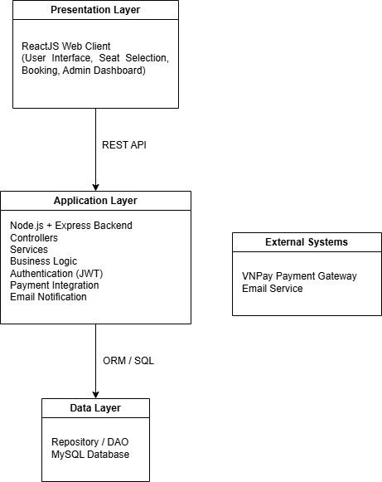

1.2 Package Diagram
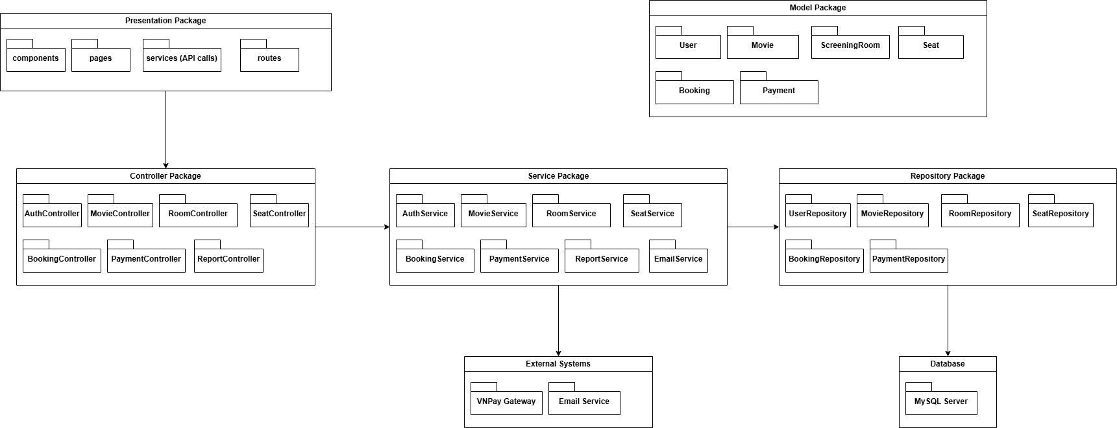

Package Descriptions
No | Package | Description
01 | Presentation Package | The Presentation Package is responsible for handling user interface and client-side interactions. It manages the display of pages and communicates with backend APIs.
02 | Controller Package | The Controller Package handles incoming HTTP requests from the client and delegates business processing to the appropriate services
03 | Service Package | The Service Package contains the core business logic of the system. It processes data, applies business rules, and coordinates with repositories and external systems.
04 | Repository Package | The Repository Package is responsible for data access and persistence. It communicates directly with the database.
05 | Model Package | The Model Package defines the core domain entities of the system.
06 | External Systems | This package represents third-party systems integrated with the application.
07 | Database | The system uses MySQL Server for data storage and persistence.

2. Database Design

2.1 Database diagram

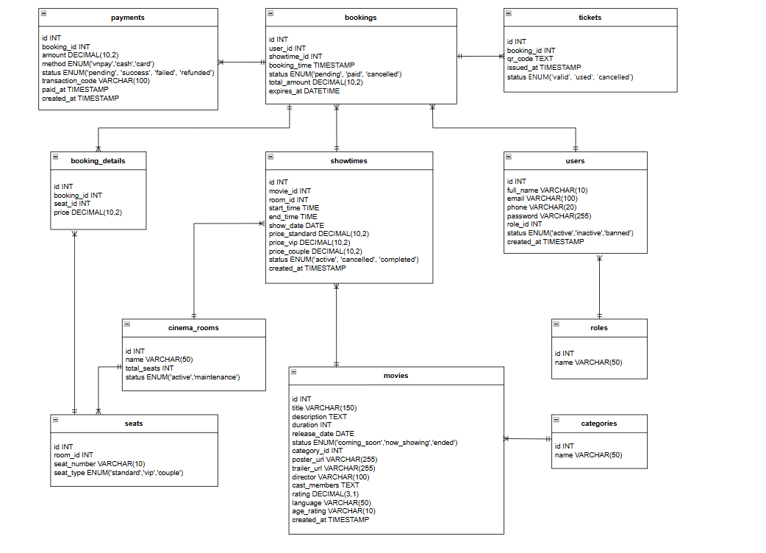

2.2.Table Descriptions

2.2.1 Users

No | Field | Data Type | PK | FK | UN | NN | Description
1 | id | INT | X |  |  | X | Unique identifier of user (auto increment).
2 | full_name | VARCHAR(100) |  |  |  | X | User full name.
3 | email | VARCHAR(100) |  |  | X | X | User email address.
4 | phone | VARCHAR(20) |  |  |  |  | User contact number.
5 | password | VARCHAR(255) |  |  |  | X | Encrypted password.
6 | role_id | INT |  | X |  | X | Reference to user role.
7 | status | ENUM('ACTIVE','INACTIVE') |  |  |  | X | Account status.
8 | created_at | TIMESTAMP |  |  |  | X | Account creation time.

2.2.2 Roles

No | Field | Data Type | PK | FK | UN | NN | Description
1 | id | INT | X |  |  | X | Unique role identifier.
2 | name | VARCHAR(50) |  |  | X | X | Role name (Admin, Manager, Customer, Staff).

2.2.3 Movies

No | Field | Data Type | PK | FK | UN | NN | Description
1 | id | INT | X |  |  | X | Movie identifier.
2 | title | VARCHAR(150) |  |  |  | X | Movie title.
3 | description | TEXT |  |  |  |  | Movie description.
4 | duration | INT |  |  |  | X | Movie duration in minutes.
5 | release_date | DATE |  |  |  |  | Release date.
6 | status | ENUM('NOW_SHOWING','COMING_SOON') |  |  |  | X | Movie status.
7 | category_id | INT |  | X |  | X | Reference to movie category.

2.2.4 Categories

No | Field | Data Type | PK | FK | UN | NN | Description
1 | id | INT | X |  |  | X | Category identifier.
2 | name | VARCHAR(50) |  |  | X | X | Category name.

2.2.5 Cinema_Rooms

No | Field | Data Type | PK | FK | UN | NN | Description
1 | id | INT | X |  |  | X | Room identifier.
2 | name | VARCHAR(50) |  |  | X | X | Room name or number.
3 | total_seats | INT |  |  |  | X | Total seating capacity.

2.2.6 Seats

No | Field | Data Type | PK | FK | UN | NN | Description
1 | id | INT | X |  |  | X | Seat identifier.
2 | room_id | INT |  | X |  | X | Reference to the cinema room.
3 | seat_number | VARCHAR(10) |  |  |  | X | Seat label (A1, B5...).
4 | seat_type | ENUM('NORMAL','VIP') |  |  |  | X | Seat category.

2.2.7 Showtimes

No | Field | Data Type | PK | FK | UN | NN | Description
1 | id | INT | X |  |  | X | Showtime identifier.
2 | movie_id | INT |  | X |  | X | Reference movie.
3 | room_id | INT |  | X |  | X | Screening room.
4 | start_time | TIME |  |  |  | X | Movie start time.
5 | end_time | TIME |  |  |  | X | Movie end time.
6 | show_date | DATE |  |  |  | X | Screening date.

2.2.8 Bookings

No | Field | Data Type | PK | FK | UN | NN | Description
1 | id | INT | X |  |  | X | Booking identifier.
2 | user_id | INT |  | X |  | X | Customer making booking.
3 | showtime_id | INT |  | X |  | X | Selected showtime.
4 | booking_time | TIMESTAMP |  |  |  | X | Booking timestamp.
5 | status | ENUM('PENDING','CONFIRMED','CANCELLED') |  |  |  | X | Booking status
6 | total_amount | DECIMAL(10,2) |  |  |  | X | Total booking price.

2.2.9 Booking_Details

No | Field | Data Type | PK | FK | UN | NN | Description
1 | id | INT | X |  |  | X | Booking detail identifier.
2 | booking_id | INT |  | X |  | X | Reference booking.
3 | seat_id | INT |  | X |  | X | Reserved seat.
4 | price | DECIMAL(10,2) |  |  |  | X | Seat price.

2.2.10 Payments

No | Field | Data Type | PK | FK | UN | NN | Description
1 | id | INT | X |  |  | X | Payment identifier.
2 | booking_id | INT |  | X |  | X | Related booking.
3 | amount | DECIMAL(10,2) |  |  |  | X | Payment amount.
4 | method | ENUM('VNPAY','CASH') |  |  |  | X | Payment method.
5 | status | ENUM('PENDING','SUCCESS','FAILED') |  |  |  | X | Payment status.
6 | transaction_code | VARCHAR(100) |  |  | X |  | Payment transaction code.
7 | paid_at | TIMESTAMP |  |  |  |  | Payment time.

2.2.11 Tickets

No | Field | Data Type | PK | FK | UN | NN | Description
1 | id | INT | X |  |  | X | Ticket identifier.
2 | booking_id | INT |  | X |  | X | Related booking.
3 | qr_code | VARCHAR(255) |  |  | X | X | QR code for verification.
4 | issued_at | TIMESTAMP |  |  |  | X | Ticket issue time.
5 | status | ENUM('VALID','USED','EXPIRED') |  |  |  | X | Ticket status.

3. Detailed Design

3.1 Authentication

3.1.1 Class Diagram
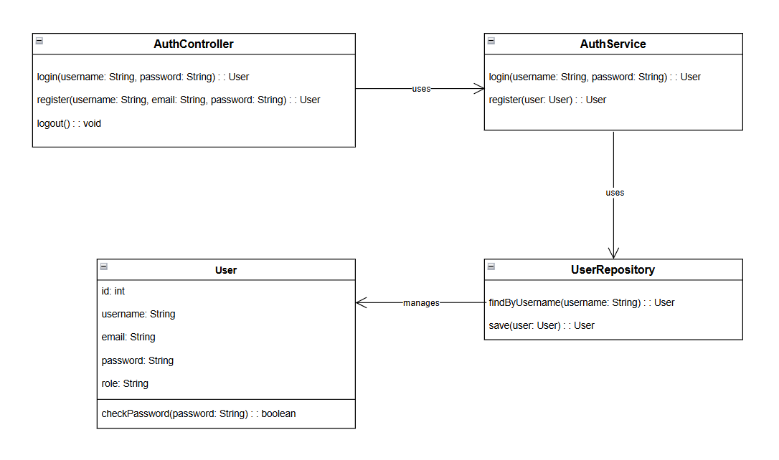

3.1.2 Sequence Diagrams

- Register
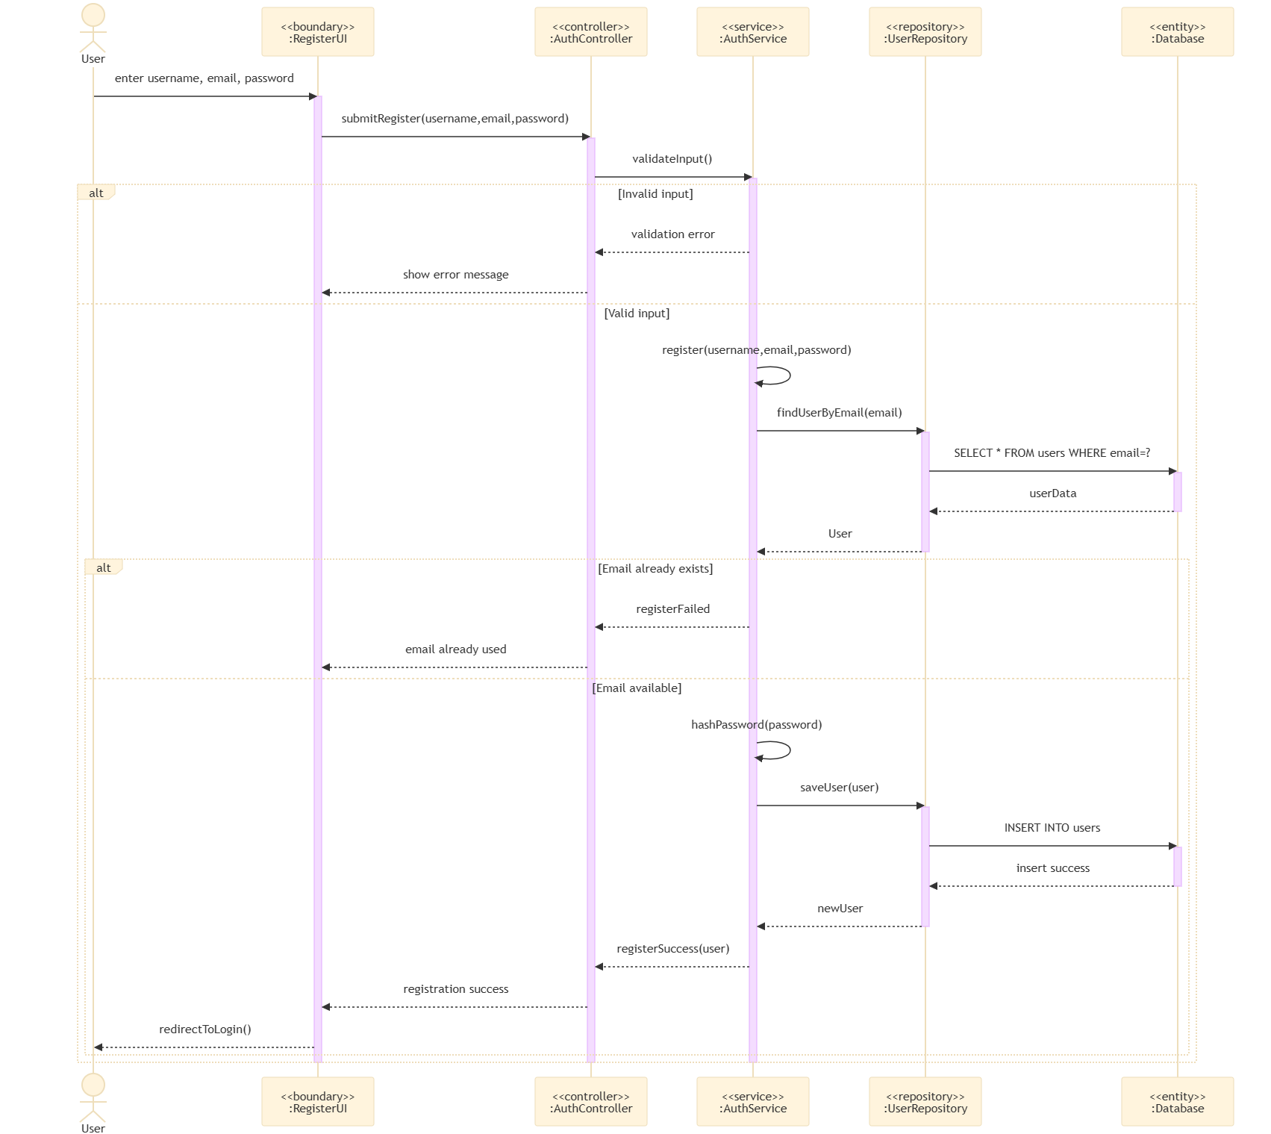

- Login
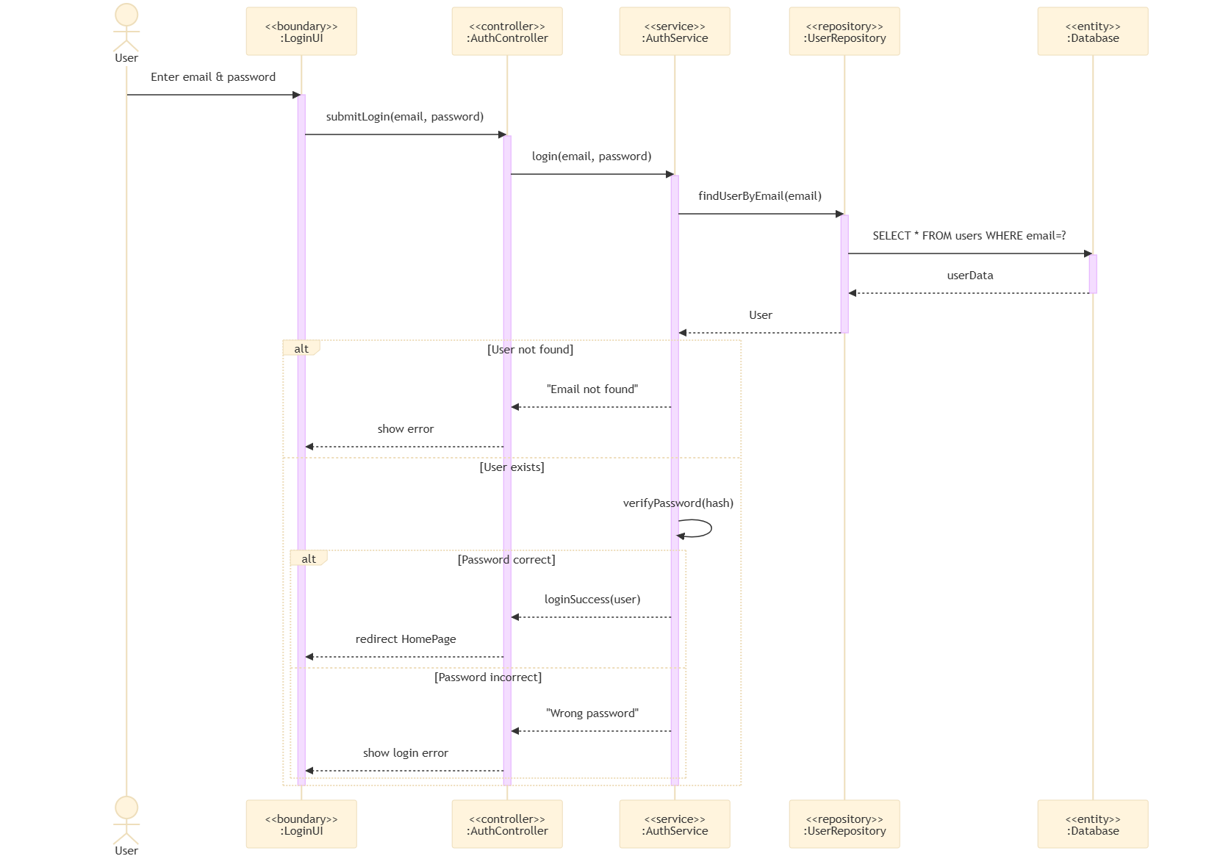

3.2 Ticket Verification Request

3.2.1 Class Diagram

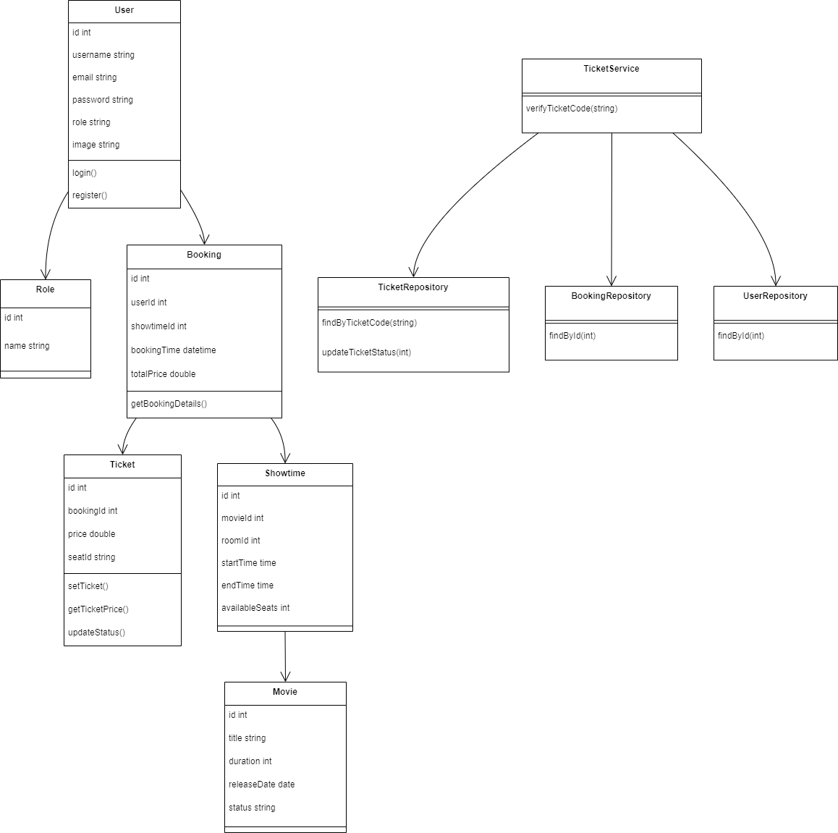

3.2.2 Sequence Diagrams

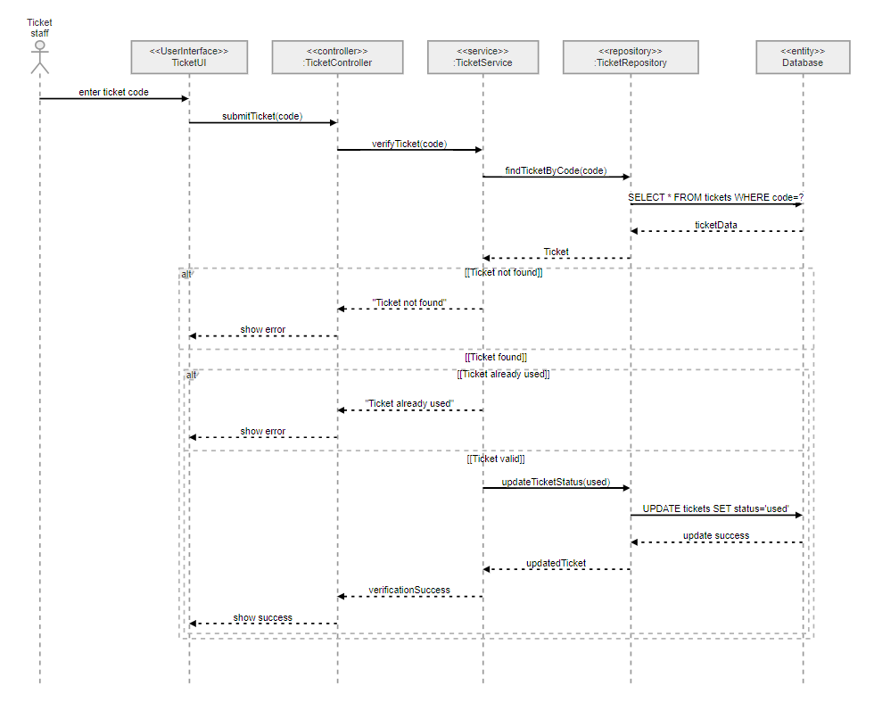

3.3 Schedule Movie Showtime

3.3.1 Class Diagram
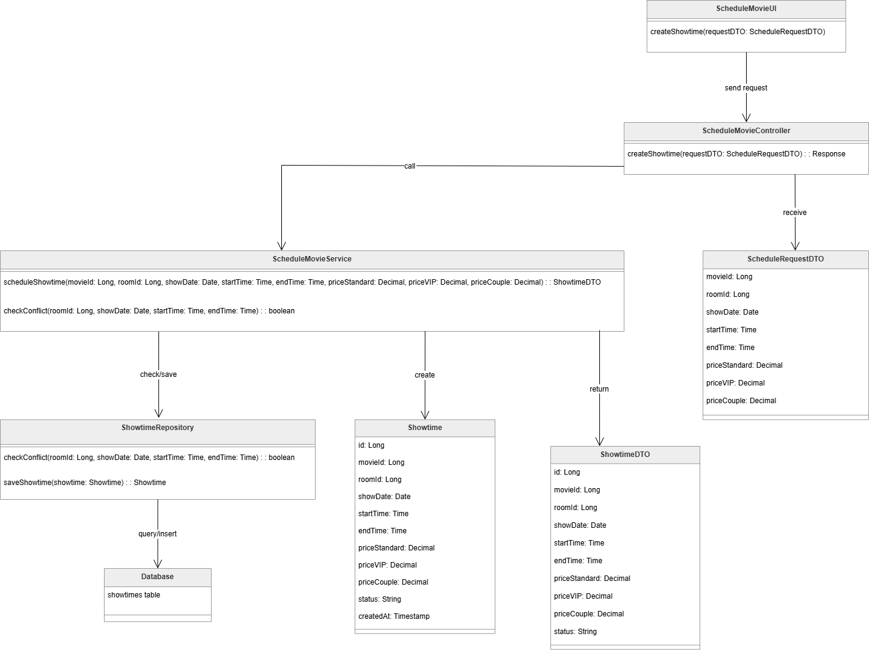

3.3.2 Sequence Diagrams

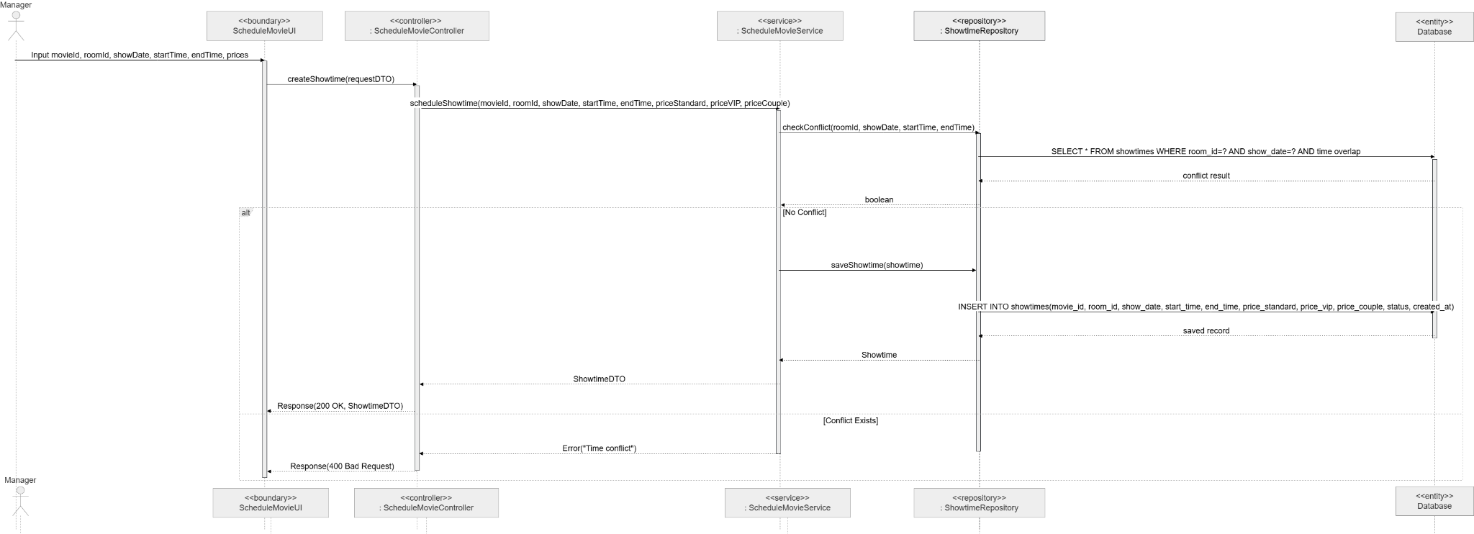

3.4 Book Movie Ticket

3.4.1 Class Diagram

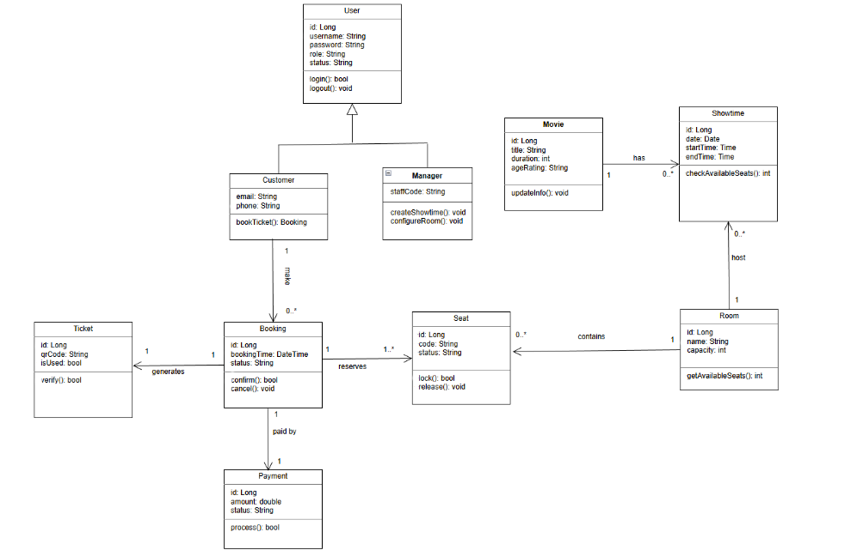

3.4.2 Sequence Diagrams
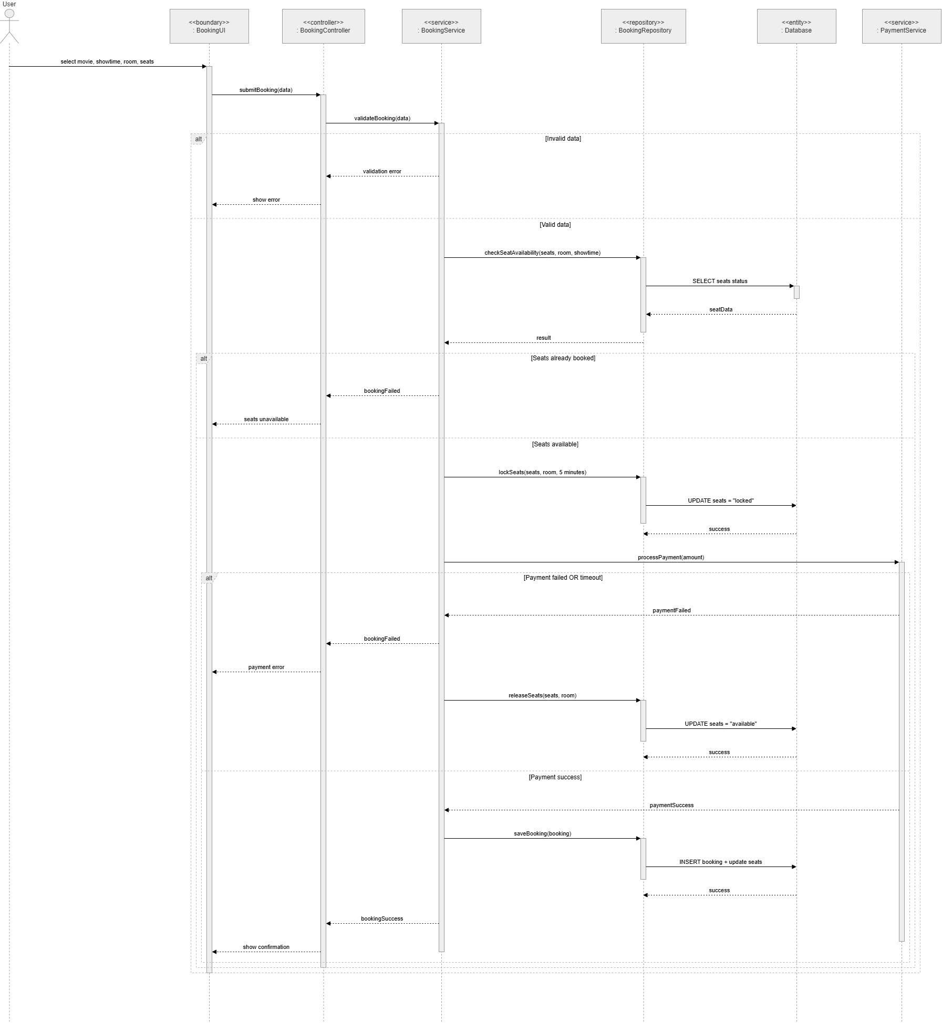

3.5 Configure Movie

3.5.1 Class Diagram

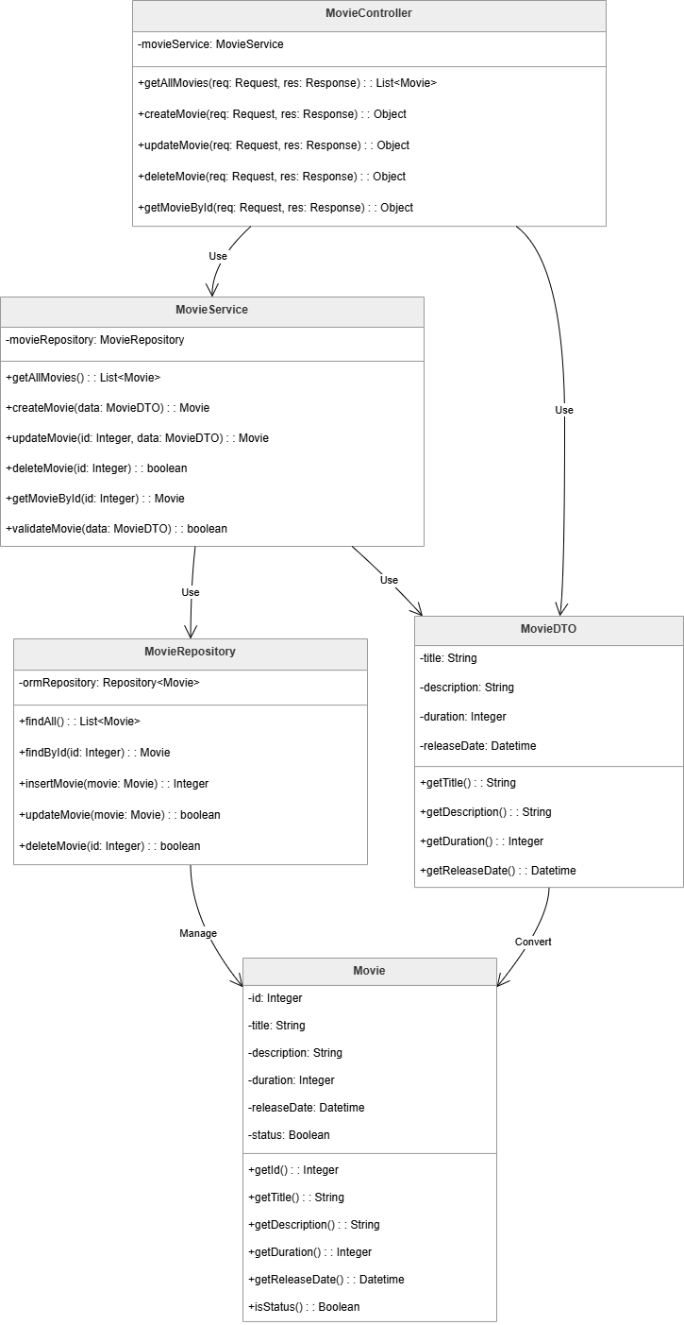

3.5.2 Sequence Diagrams
- Open Configure Movie

- Add Movie
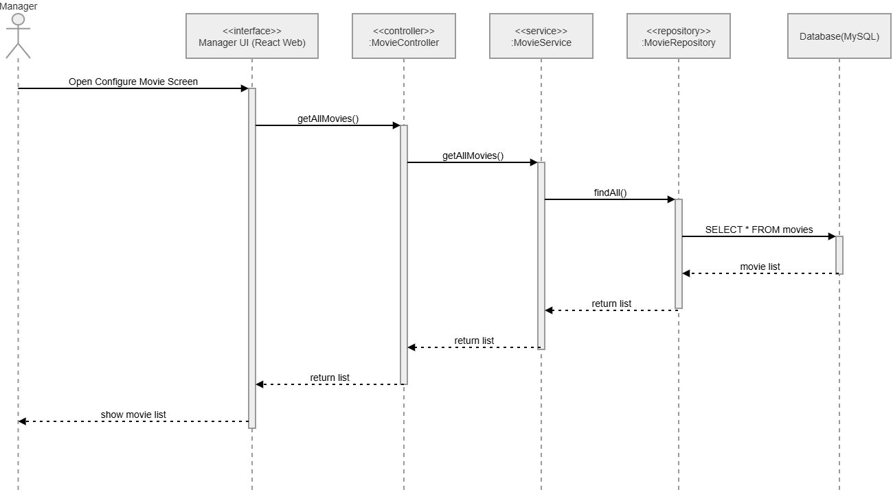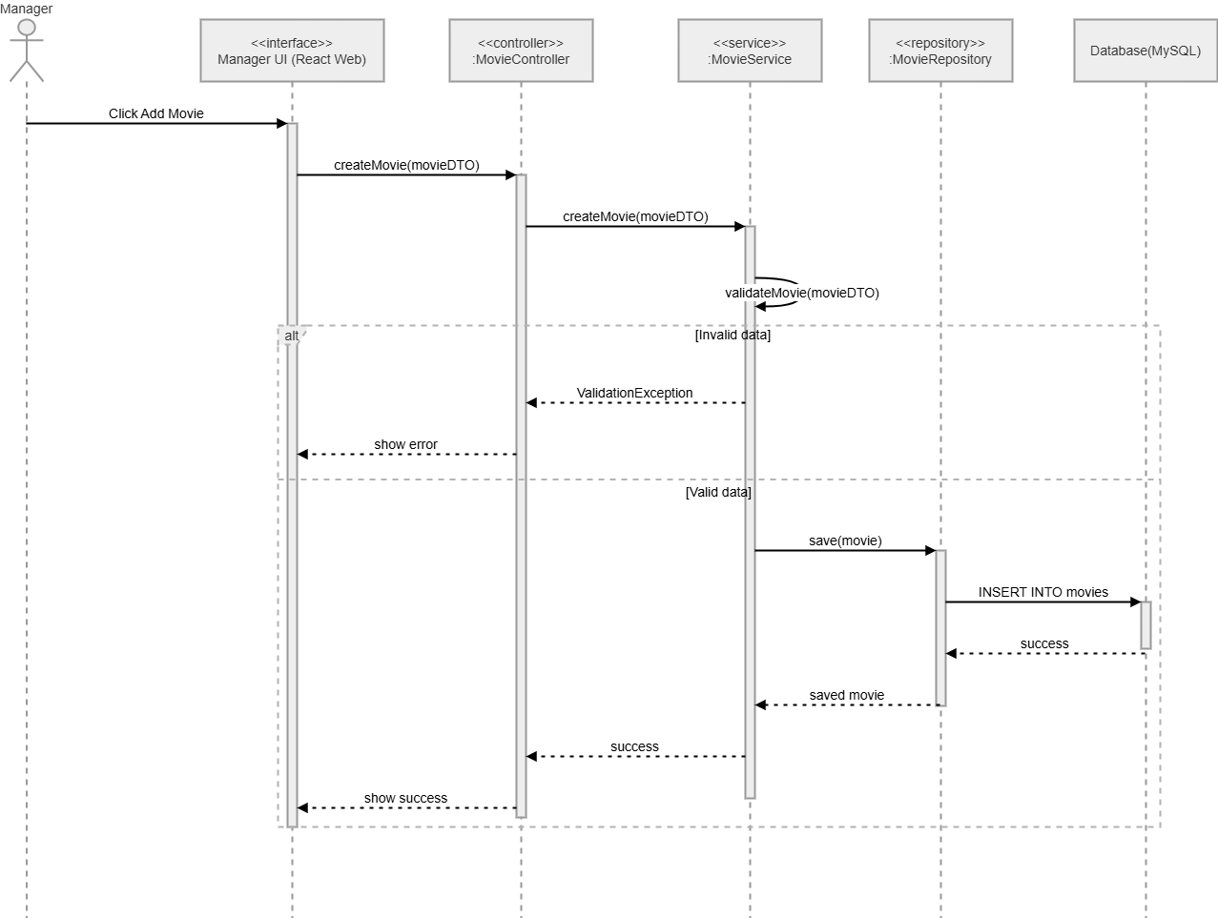
- Update Movie
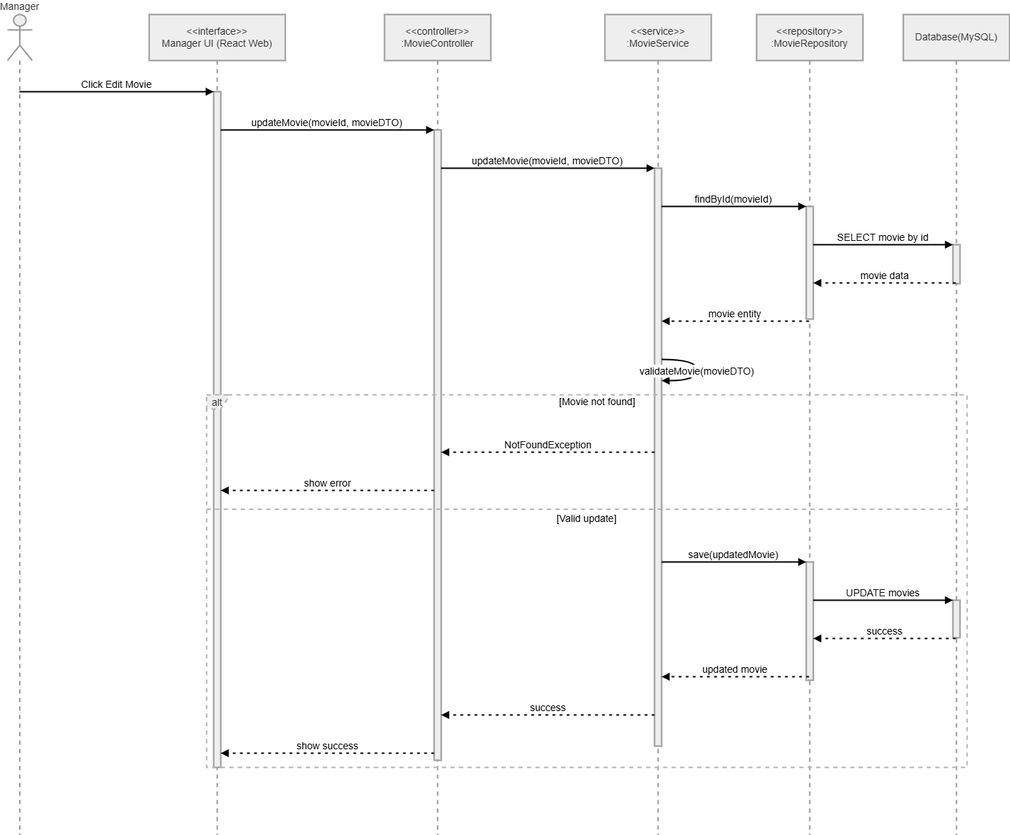
- Delete Movie
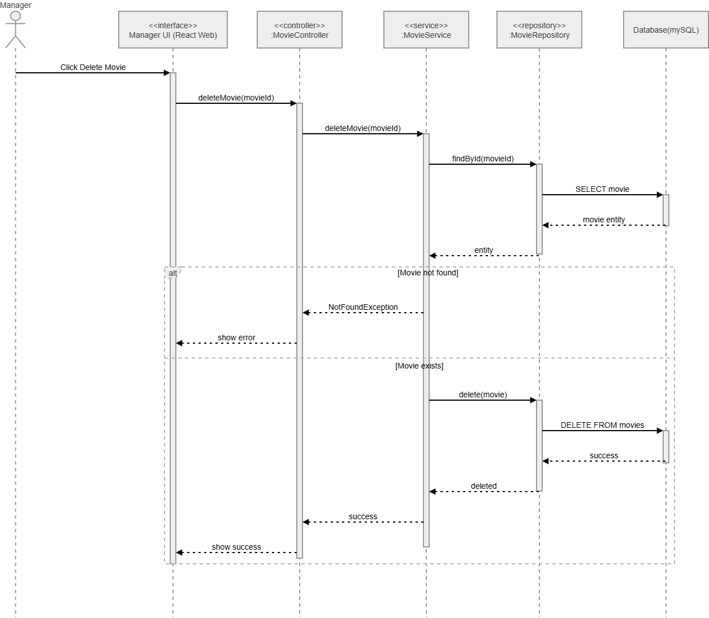

3.6 Configure Room & Seat

3.6.1 Class Diagram

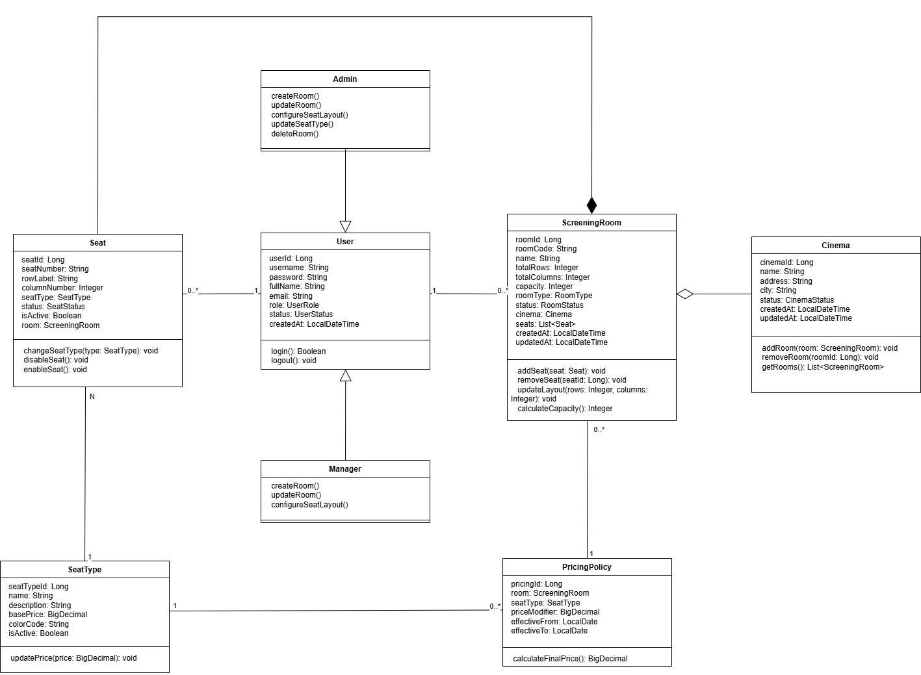

3.6.2 Sequence Diagrams
a, Room
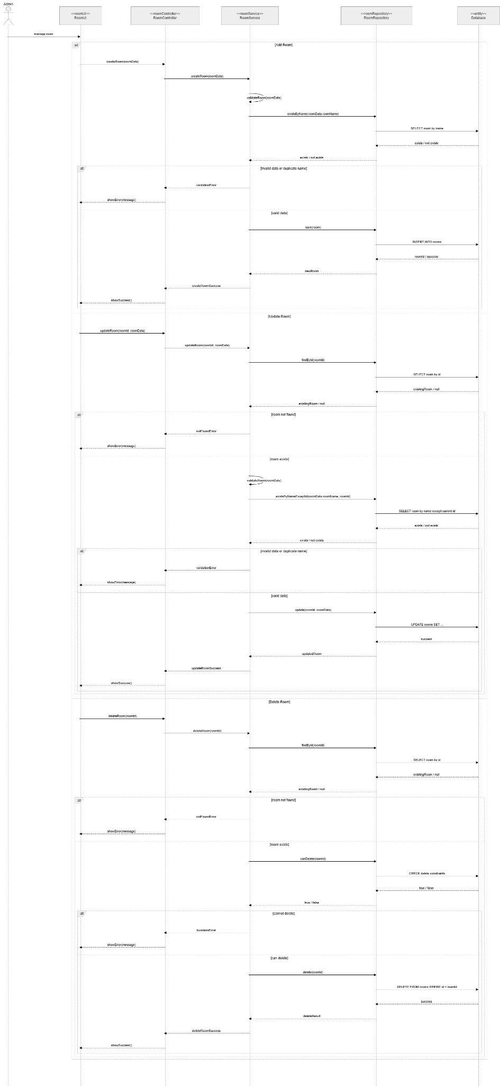
b, Seat
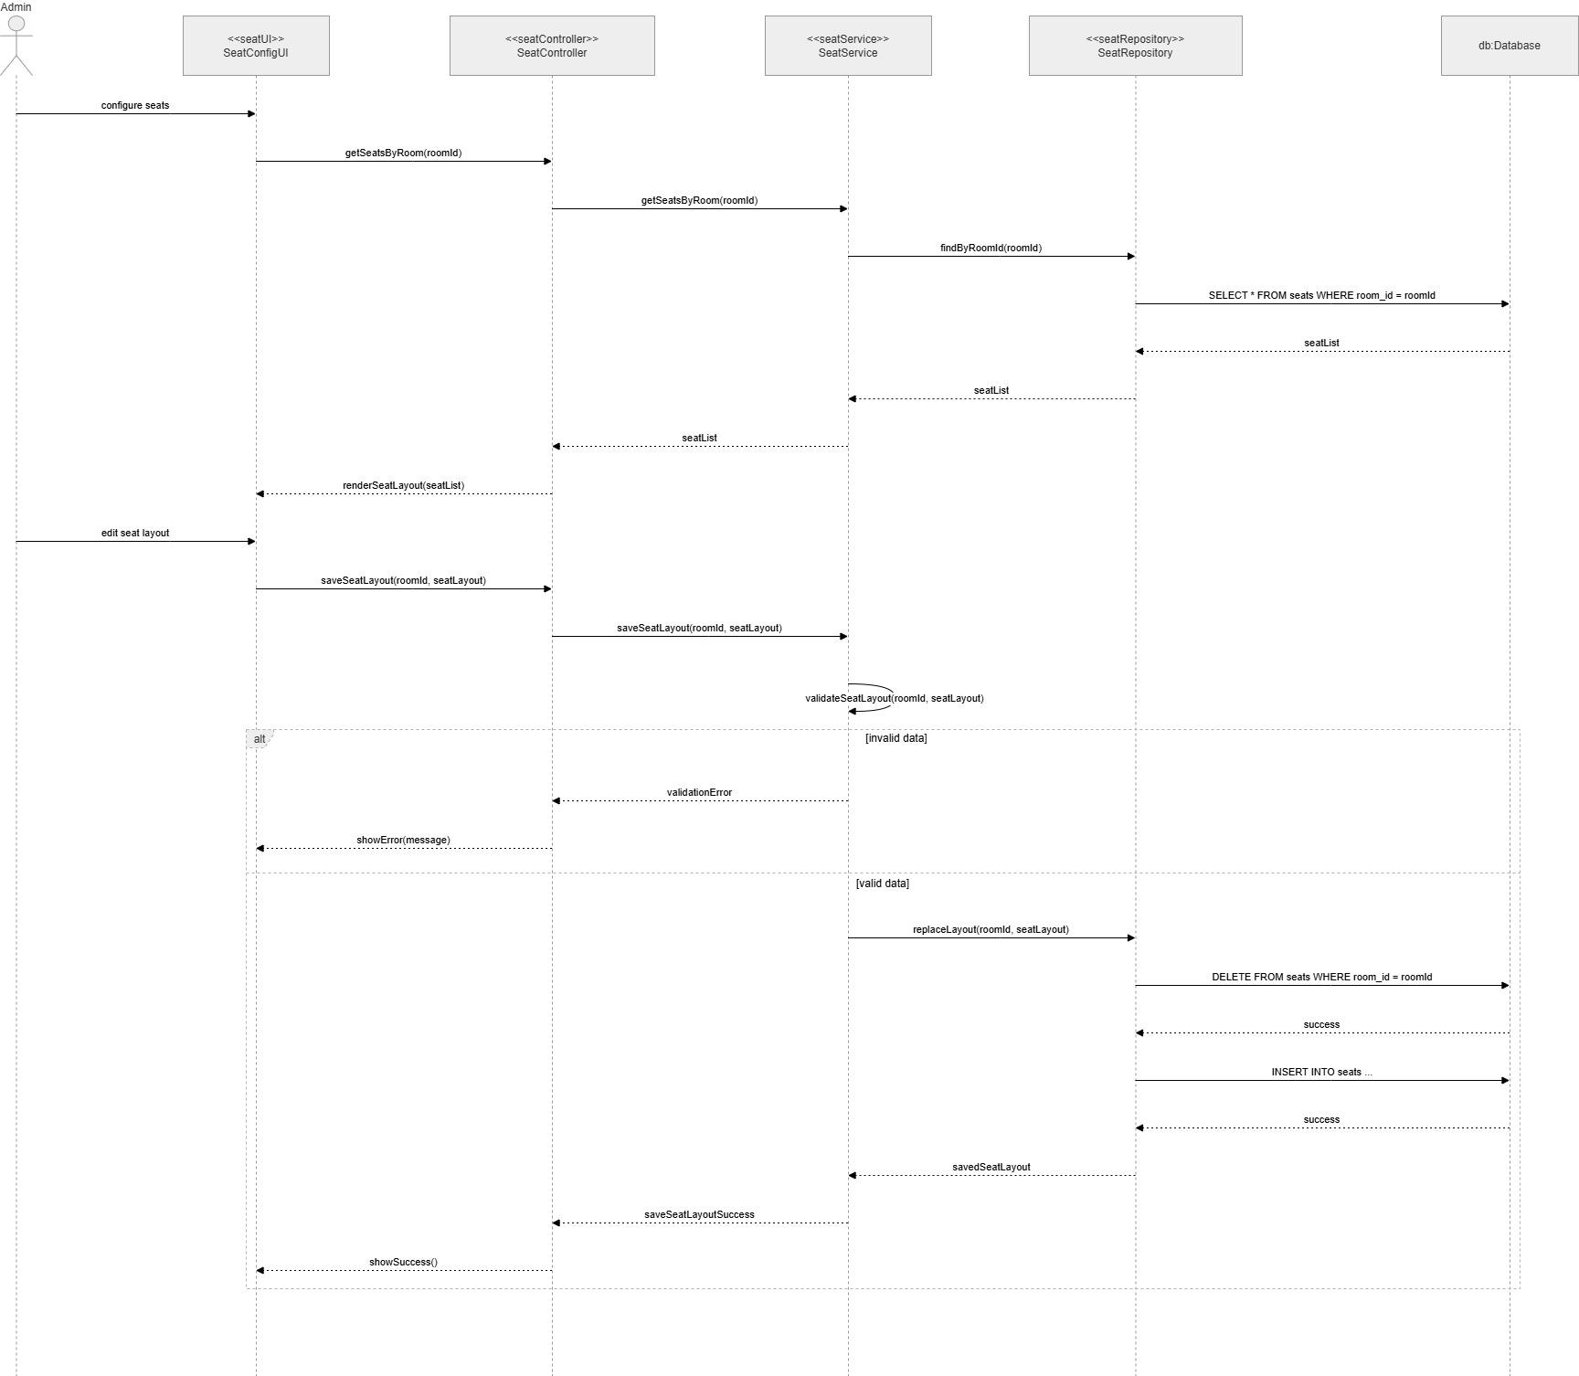

3.7 User Account Management

3.7.1 Class Diagram
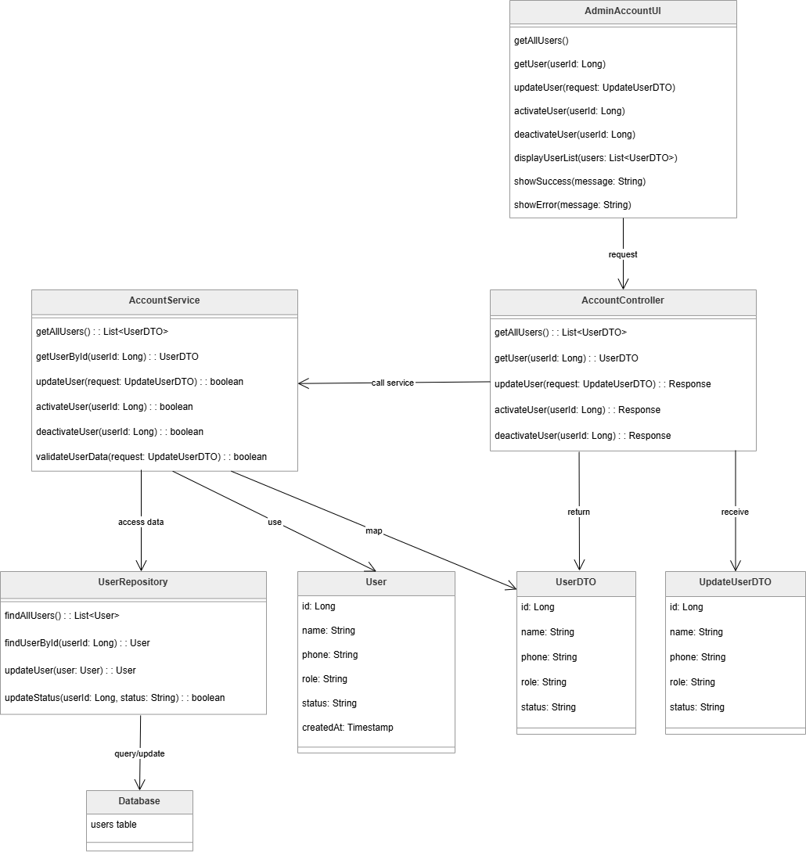

3.7.2 Sequence Diagrams

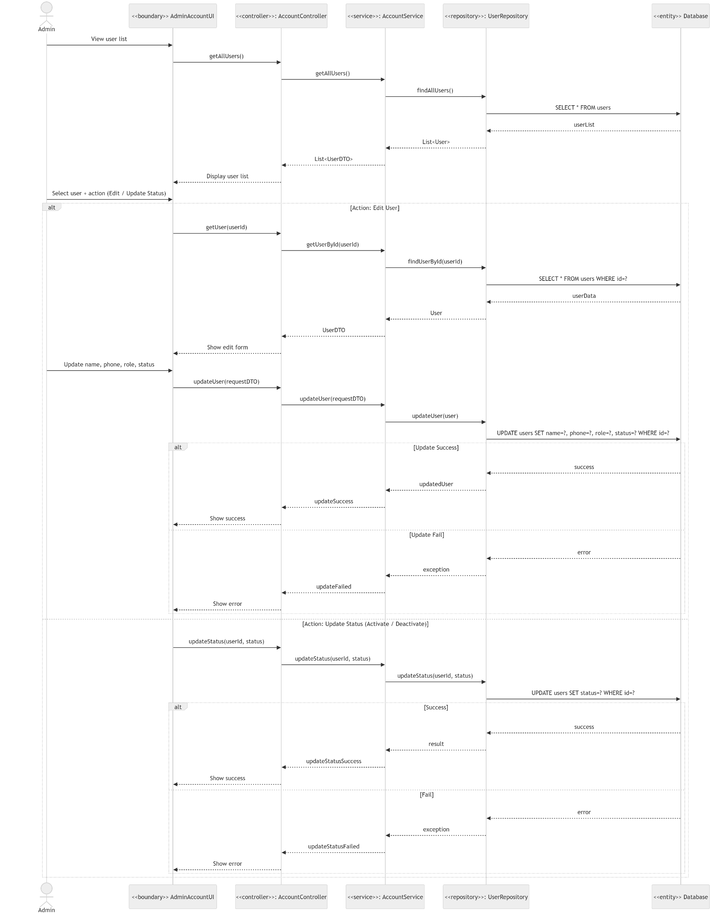

3.8 Class specifications

3.8.1 Entity

3.8.1.1 User (users)

No | Name | Description
Attributes
01 | id | Visibility: Private (-)  Type: Int  Purpose: Unique identifier for the account
02 | full_name | Visibility: Private (-)  Type: String  Purpose: Full name of the user
03 | email | Visibility: Private (-)  Type: String (VARCHAR 100)  Purpose: Stores the login email
04 | phone | Visibility: Private (-)  Type: String (VARCHAR 20)  Purpose: Phone number of the user
05 | password | Visibility: Private (-)  Type: String (VARCHAR 255)  Purpose: Stores the encrypted password
06 | role_id | Visibility: Private (-)  Type: Int  Purpose: Foreign key referencing the roles table
07 | status | Visibility: Private (-)  Type: Enum  Purpose: Indicates whether the user account is active
08 | created_at | Visibility: Private (-)  Type: Timestamp  Purpose: Date and time when the account was created
Methods/Operations
01 | register() | Visibility: Public (+)  Purpose: Creates a new user account
02 | login() | Visibility: Public (+)  Purpose: Authenticates user with email and password
03 | updateProfile() | Visibility: Public (+)  Purpose: Updates user profile information
04 | changePassword() | Visibility: Public (+)  Purpose: Changes the user password
05 | getRole() | Visibility: Public (+)  Purpose: Returns the role associated with the user

3.8.1.2 Role (roles)

No | Name | Description
Attributes
01 | id | Visibility: Private (-)  Type: Int  Purpose: Unique identifier for the role
02 | name | Visibility: Private (-)  Type: String (VARCHAR 50)  Purpose: Name of the role (e.g., admin, user)
Methods/Operations
01 | getUsers() | Visibility: Public (+)  Purpose: Returns list of users with this role
02 | assignRole() | Visibility: Public (+)  Purpose: Assigns this role to a user
3.8.1.3 Movie (movies)
No | Name | Description
Attributes
01 | id | Visibility: Private (-)  Type: Int  Purpose: Unique identifier for the movie
02 | title | Visibility: Private (-)  Type: String (VARCHAR 150)  Purpose: Title of the movie
03 | description | Visibility: Private (-)  Type: Text  Purpose: Detailed description or synopsis of the movie
04 | duration | Visibility: Private (-)  Type: Int  Purpose: Duration of the movie in minutes
05 | release_date | Visibility: Private (-)  Type: Date  Purpose: Date when the movie was released
06 | status | Visibility: Private (-)  Type: Enum  Purpose: Indicates the current status of the movie (e.g., now_showing, upcoming)
07 | category_id | Visibility: Private (-)  Type: Int  Purpose: Foreign key referencing the categories table
Methods/Operations
01 | getCategory() | Visibility: Public (+)  Purpose: Returns the category of the movie
02 | getShowtimes() | Visibility: Public (+)  Purpose: Returns all showtimes for this movie
03 | updateStatus() | Visibility: Public (+)  Purpose: Updates the current status of the movie
3.8.1.4 Category (categories)
No | Name | Description
Attributes
01 | id | Visibility: Private (-)  Type: Int  Purpose: Unique identifier for the category
02 | name | Visibility: Private (-)  Type: String (VARCHAR 50)  Purpose: Name of the movie category (e.g., Action, Drama)
Methods/Operations
01 | getMovies() | Visibility: Public (+)  Purpose: Returns all movies belonging to this category
3.8.1.5 CinemaRoom (cinema_rooms)
No | Name | Description
Attributes
01 | id | Visibility: Private (-)  Type: Int  Purpose: Unique identifier for the cinema room
02 | name | Visibility: Private (-)  Type: String (VARCHAR 50)  Purpose: Name or label of the cinema room
03 | total_seats | Visibility: Private (-)  Type: Int  Purpose: Total number of seats in the room
Methods/Operations
01 | getSeats() | Visibility: Public (+)  Purpose: Returns all seats in this room
02 | getShowtimes() | Visibility: Public (+)  Purpose: Returns all showtimes scheduled in this room
03 | getAvailableSeats() | Visibility: Public (+)  Purpose: Returns available seats for a specific showtime
3.8.1.6 Seat (seats)
No | Name | Description
Attributes
01 | id | Visibility: Private (-)  Type: Int  Purpose: Unique identifier for the seat
02 | room_id | Visibility: Private (-)  Type: Int  Purpose: Foreign key referencing the cinema_rooms table
03 | seat_number | Visibility: Private (-)  Type: String (VARCHAR)  Purpose: Label or number of the seat (e.g., A1, B2)
04 | seat_type | Visibility: Private (-)  Type: Enum  Purpose: Type of seat (e.g., standard, VIP)
Methods/Operations
01 | getRoom() | Visibility: Public (+)  Purpose: Returns the cinema room this seat belongs to
02 | isAvailable() | Visibility: Public (+)  Purpose: Checks if the seat is available for a given showtime
3.8.1.7 Showtime (showtimes)
No | Name | Description
Attributes
01 | id | Visibility: Private (-)  Type: Int  Purpose: Unique identifier for the showtime
02 | movie_id | Visibility: Private (-)  Type: Int  Purpose: Foreign key referencing the movies table
03 | room_id | Visibility: Private (-)  Type: Int  Purpose: Foreign key referencing the cinema_rooms table
04 | start_time | Visibility: Private (-)  Type: Time  Purpose: Start time of the screening
05 | end_time | Visibility: Private (-)  Type: Time  Purpose: End time of the screening
06 | show_date | Visibility: Private (-)  Type: Date  Purpose: Date of the screening
Methods/Operations
01 | getMovie() | Visibility: Public (+)  Purpose: Returns the movie associated with this showtime
02 | getRoom() | Visibility: Public (+)  Purpose: Returns the cinema room for this showtime
03 | getBookings() | Visibility: Public (+)  Purpose: Returns all bookings for this showtime
04 | getAvailableSeats() | Visibility: Public (+)  Purpose: Returns list of available seats for this showtime
3.8.1.8 Booking (bookings)
No | Name | Description
Attributes
01 | id | Visibility: Private (-)  Type: Int  Purpose: Unique identifier for the booking
02 | user_id | Visibility: Private (-)  Type: Int  Purpose: Foreign key referencing the users table
03 | showtime_id | Visibility: Private (-)  Type: Int  Purpose: Foreign key referencing the showtimes table
04 | booking_time | Visibility: Private (-)  Type: Timestamp  Purpose: Date and time when the booking was made
05 | status | Visibility: Private (-)  Type: Enum  Purpose: Current status of the booking (e.g., pending, confirmed, cancelled)
06 | total_amount | Visibility: Private (-)  Type: Decimal (10,2)  Purpose: Total price for the booking
Methods/Operations
01 | createBooking() | Visibility: Public (+)  Purpose: Creates a new booking for a user and showtime
02 | cancelBooking() | Visibility: Public (+)  Purpose: Cancels an existing booking
03 | getDetails() | Visibility: Public (+)  Purpose: Returns booking detail records (seats booked)
04 | getTickets() | Visibility: Public (+)  Purpose: Returns all tickets issued for this booking
05 | getPayment() | Visibility: Public (+)  Purpose: Returns the payment associated with this booking
06 | calculateTotal() | Visibility: Public (+)  Purpose: Calculates the total amount based on seats and prices

3.8.1.9 BookingDetail (booking_details)

No | Name | Description
Attributes
01 | id | Visibility: Private (-)  Type: Int  Purpose: Unique identifier for the booking detail record
02 | booking_id | Visibility: Private (-)  Type: Int  Purpose: Foreign key referencing the bookings table
03 | seat_id | Visibility: Private (-)  Type: Int  Purpose: Foreign key referencing the seats table
04 | price | Visibility: Private (-)  Type: Decimal (10,2)  Purpose: Price charged for this specific seat
Methods/Operations
01 | getBooking() | Visibility: Public (+)  Purpose: Returns the parent booking record
02 | getSeat() | Visibility: Public (+)  Purpose: Returns the seat associated with this detail
3.8.1.10 Ticket (tickets)
No | Name | Description
Attributes
01 | id | Visibility: Private (-)  Type: Int  Purpose: Unique identifier for the ticket
02 | booking_id | Visibility: Private (-)  Type: Int  Purpose: Foreign key referencing the bookings table
03 | qr_code | Visibility: Private (-)  Type: String (VARCHAR 255)  Purpose: QR code string used for ticket verification
04 | issued_at | Visibility: Private (-)  Type: Timestamp  Purpose: Date and time when the ticket was issued
05 | status | Visibility: Private (-)  Type: Enum  Purpose: Status of the ticket (e.g., valid, used, expired)
Methods/Operations
01 | generateQRCode() | Visibility: Public (+)  Purpose: Generates a unique QR code for the ticket
02 | validateTicket() | Visibility: Public (+)  Purpose: Validates the ticket at entry
03 | getBooking() | Visibility: Public (+)  Purpose: Returns the booking associated with this ticket
3.8.1.11 Payment (payments)
No | Name | Description
Attributes
01 | id | Visibility: Private (-)  Type: Int  Purpose: Unique identifier for the payment
02 | booking_id | Visibility: Private (-)  Type: Int  Purpose: Foreign key referencing the bookings table
03 | amount | Visibility: Private (-)  Type: Decimal (10,2)  Purpose: Total amount paid
04 | method | Visibility: Private (-)  Type: Enum  Purpose: Payment method used (e.g., credit_card, cash, e-wallet)
05 | status | Visibility: Private (-)  Type: Enum  Purpose: Status of the payment (e.g., pending, completed, failed)
06 | transaction_code | Visibility: Private (-)  Type: String (VARCHAR 100)  Purpose: Unique transaction code for tracking purposes
07 | paid_at | Visibility: Private (-)  Type: Timestamp  Purpose: Date and time when the payment was completed
Methods/Operations
01 | processPayment() | Visibility: Public (+)  Purpose: Processes the payment for a booking
02 | refund() | Visibility: Public (+)  Purpose: Initiates a refund for a cancelled booking
03 | getBooking() | Visibility: Public (+)  Purpose: Returns the booking associated with this payment
04 | generateTransactionCode() | Visibility: Public (+)  Purpose: Generates a unique code for the transaction

3.9 State machine diagram

3.9.1 Booking State Machine
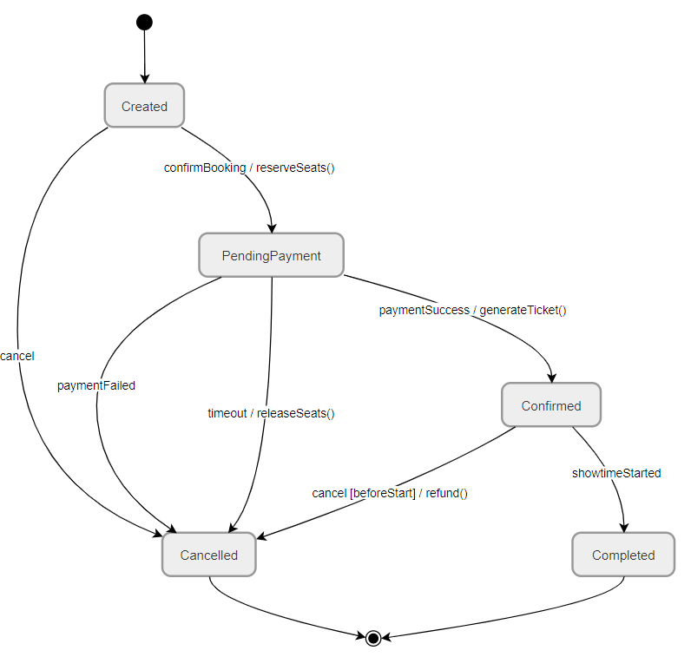

3.9.2 Seat State Machine

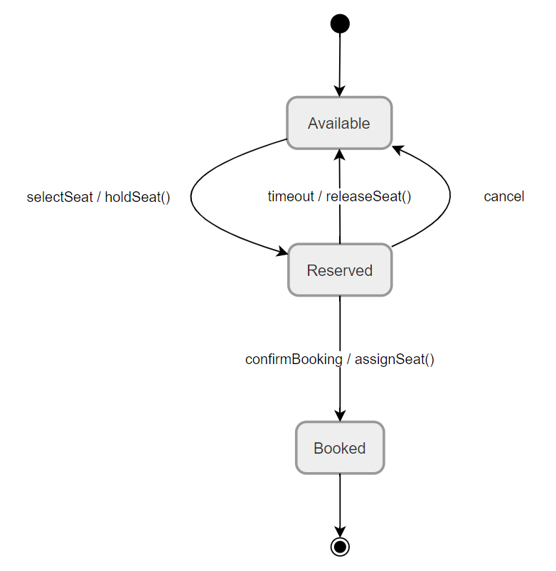

3.9.3 Showtime State Machine

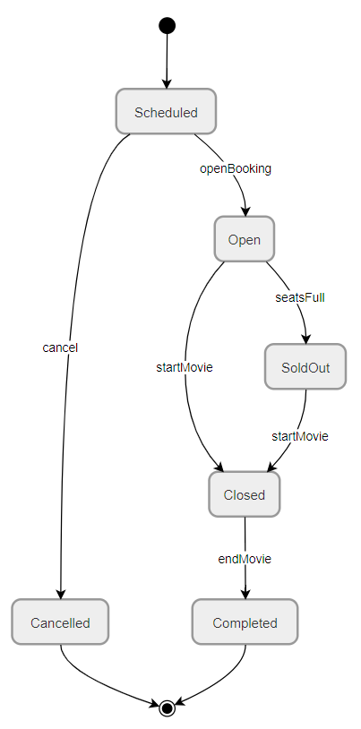

IV. Implementation

1.1. Register Flow

- Step 1: The user accesses the registration page and enters account information (email, password, and personal details).
- Step 2: The system validates the input data (email format, password strength, and duplicate account check).
- Step 3: If the information is valid, the system creates a new account and stores it in the database.
- Step 4: The user is redirected to the login page or automatically logged in and redirected to the homepage.

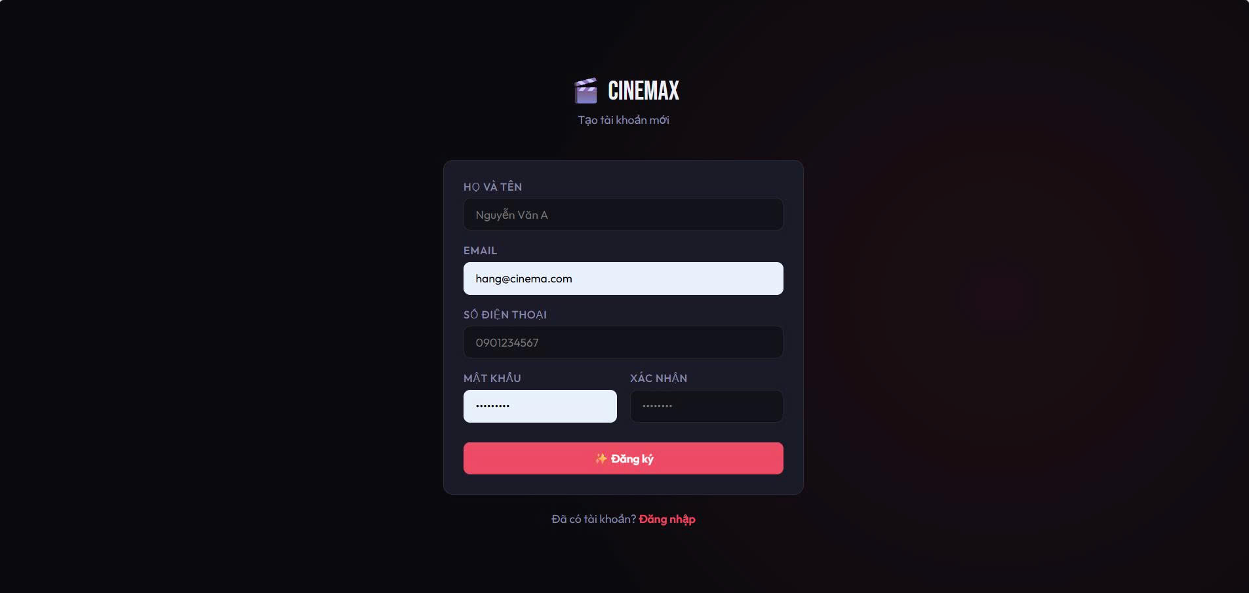

1.2. Login Flow
- Step 1: The user accesses the login page and enters their account credentials.
- Step 2: The system checks the validity of the login information and access permissions.
- Step 3: If successful, the user is directed to the homepage according to their role (Admin, Customer).
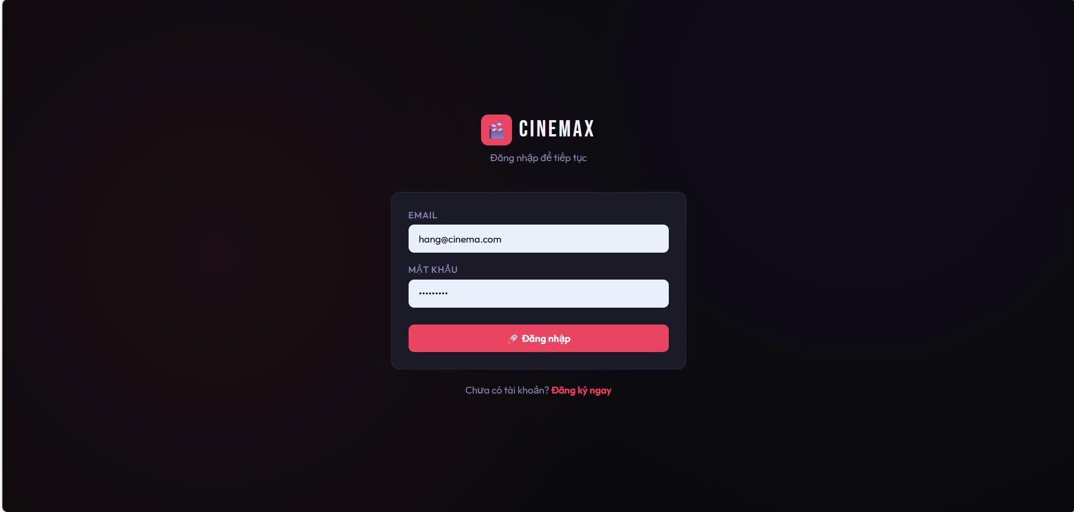

1.3 Home Page
- Step 1: The user selects the "Rooms" option from the menu to view the list of available rooms.
- Step 2: The system displays a list of rooms with details such as room name, type, price, and availability.
- Step 3: The user can filter or sort rooms based on criteria such as room type, price range, or availability.
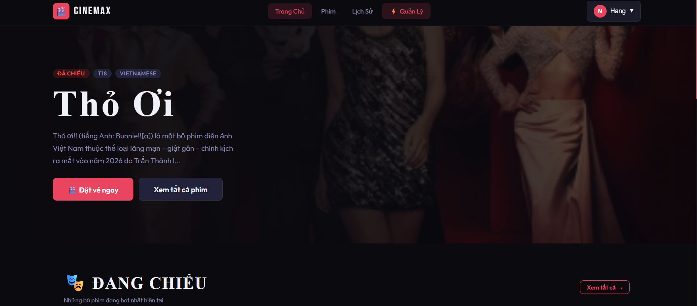

1.4 View Movie Detail
- Step 1: The user accesses the system and navigates to the movie listing page.
- Step 2: The system displays a list of movies with basic information (title, poster, genre, duration).
- Step 3: The user selects a specific movie.
- Step 4: The system retrieves detailed information about the selected movie from the database.
- Step 5: The system displays movie details (description, cast, trailer, showtimes, and ratings).
- Step 6: The user can proceed to the next action (e.g., select showtime, book tickets, or return to the movie list).

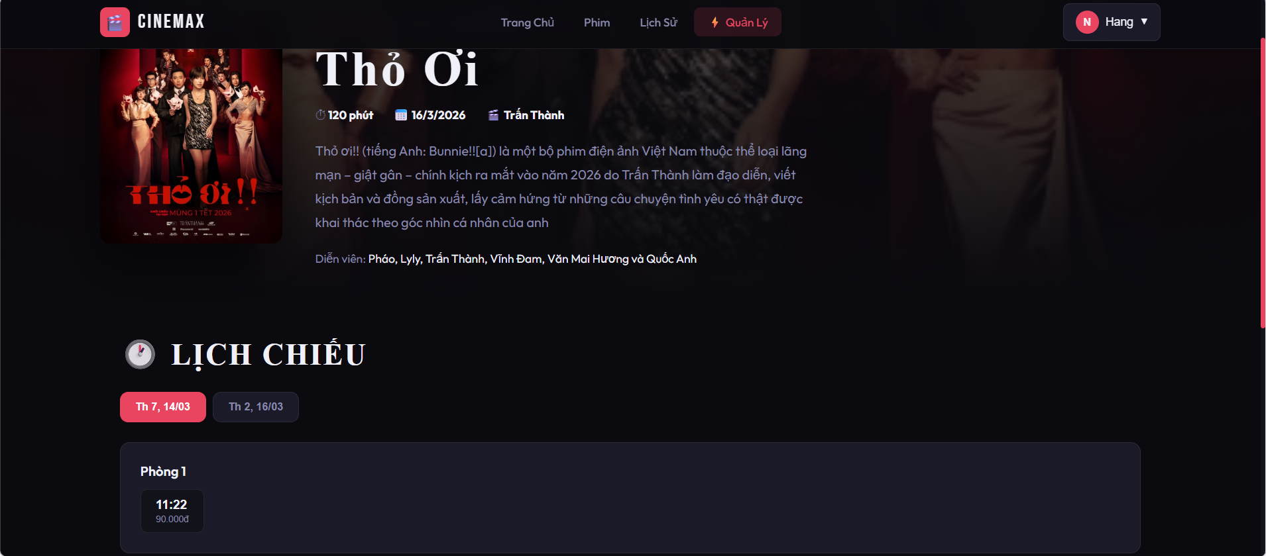

1.5 Room Browsing and Viewing Flow

- Step 1: The user accesses the system and navigates to the room browsing section.
- Step 2: The system displays a list of available rooms with basic information (room name, type, capacity, and status).
- Step 3: The user can search, filter, or sort rooms based on preferences (e.g., capacity, type, availability).
- Step 4: The user selects a specific room to view more details.
- Step 5: The system displays detailed information about the selected room (layout, seating arrangement, facilities, and schedule).
- Step 6: The user can proceed to the next action (e.g., select seats, book tickets, or return to the room list).

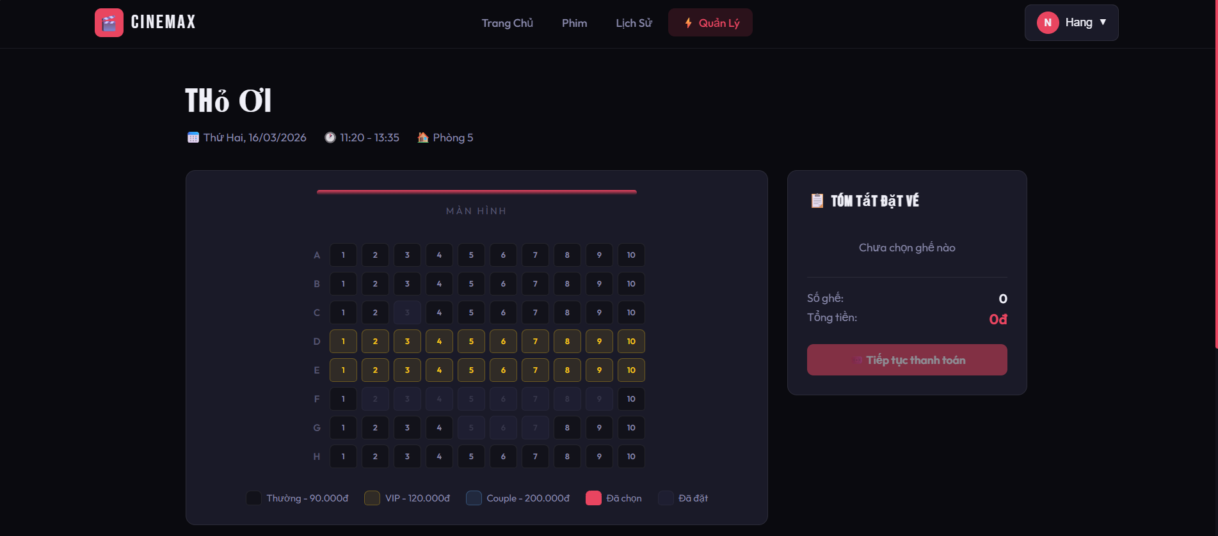

1.6 Payment
- Step 1: The user proceeds to the payment page after selecting seats and confirming booking information.
- Step 2: The system displays booking details (movie, room, seats, total price).
- Step 3: The user selects a payment method (e.g., credit card, e-wallet, or online banking).
- Step 4: The user enters payment information and confirms the payment.
- Step 5: The system sends the payment request to the payment gateway for processing.
- Step 6: The payment gateway processes the transaction and returns the result.
- Step 7: If the payment is successful, the system updates the booking status and generates the ticket.
- Step 8: If the payment fails, the system notifies the user and allows retry or cancellation.

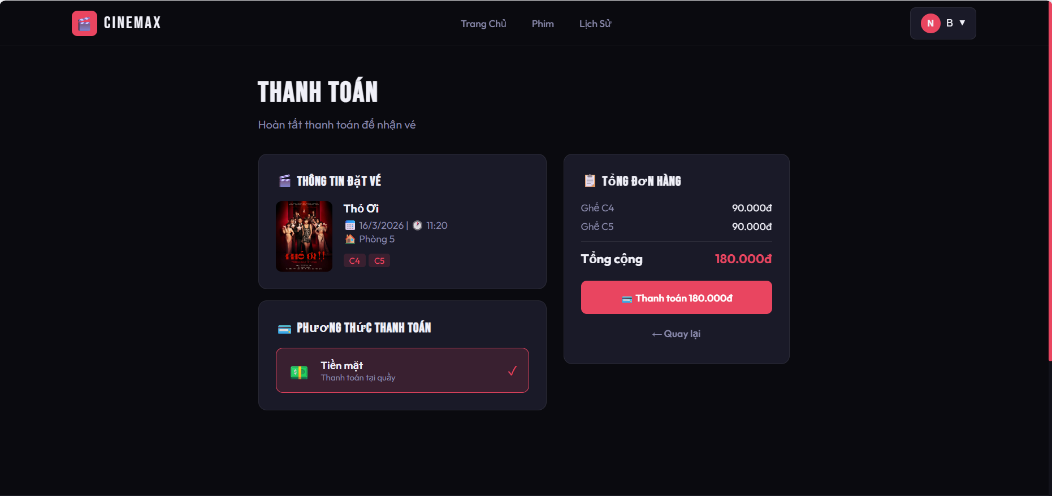

1.7 Booking History

- Step 1: The user logs into the system.
- Step 2: The user navigates to the booking history section.
- Step 3: The system retrieves the user’s booking history from the database.
- Step 4: The system displays a list of past bookings (movie, room, seats, date, and status).
- Step 5: The user selects a specific booking to view detailed information.
- Step 6: The system displays booking details (ticket information, payment status, and transaction details).
- Step 7: The user can perform additional actions (e.g., download ticket, view again, or return to the list).

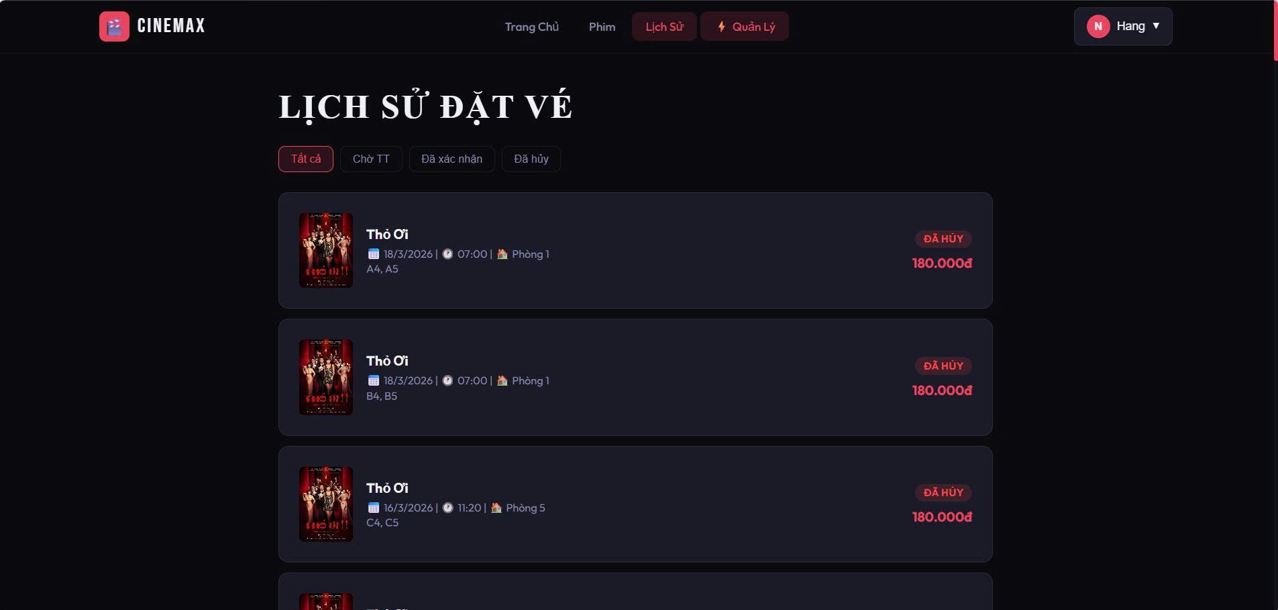

1.8 Admin Dashboard

- Step 1: The admin logs into the system
- Step 2: The system redirects to the Dashboard page.
- Step 3: The system displays overall statistics (movies, bookings, customers, revenue).
- Step 4: The admin views the 7-day revenue chart to analyze performance.
- Step 5: The system shows top-selling movies with ticket and revenue data.
- Step 6: The admin navigates through the sidebar (Movies, Showtimes, Bookings, Payments, Rooms, Users).
- Step 7: The admin selects a specific module to manage and perform actions (add, edit, delete, view details).
- Step 8: The admin logs out of the system when finished.

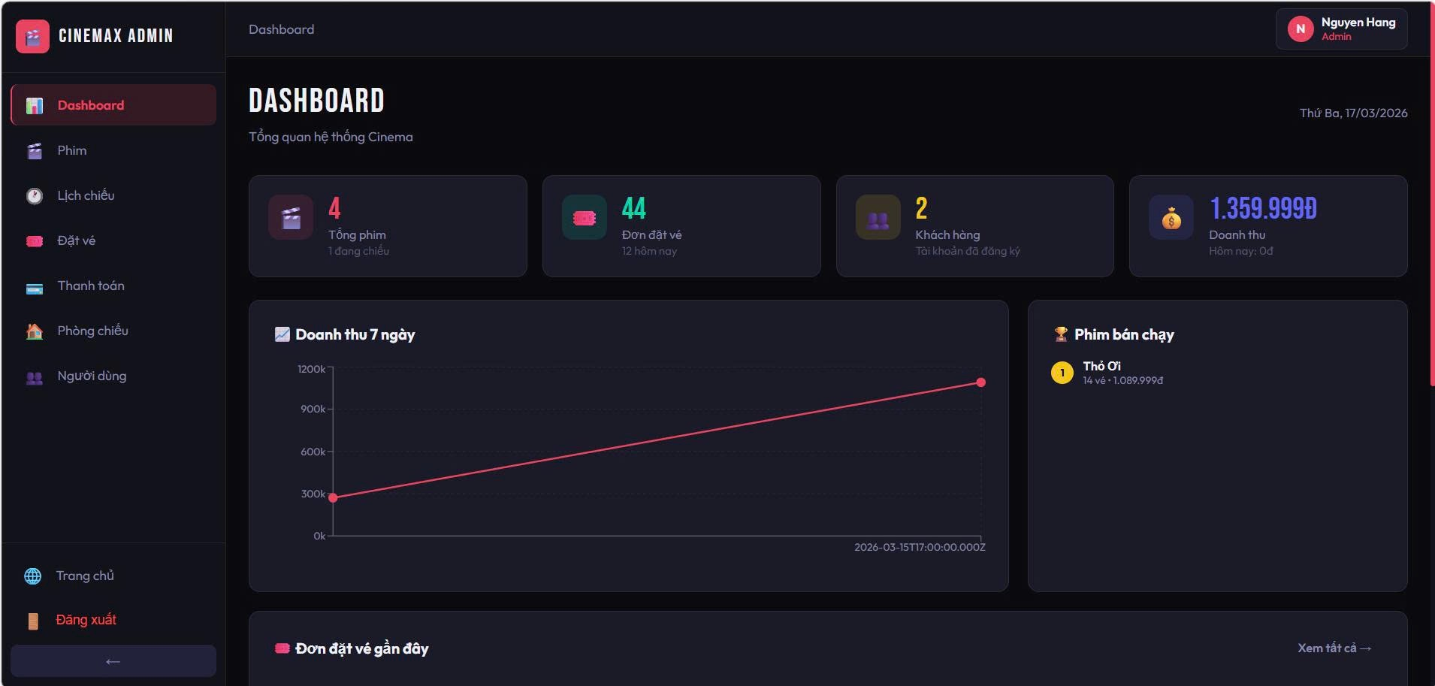

1.9 Add movie

- Step 1: The admin navigates to the Movies section.
- Step 2: The admin clicks the “Add New Movie” button.
- Step 3: The system displays the movie creation form.
- Step 4: The admin enters movie information (title, duration, release date).
- Step 5: The admin selects additional details (status, genre, language, age rating).
- Step 6: The admin inputs the director and actors.
- Step 7: The admin submits the form.
- Step 8: The system validates the data and saves the new movie to the database.
- Step 9: The system displays the updated movie list.

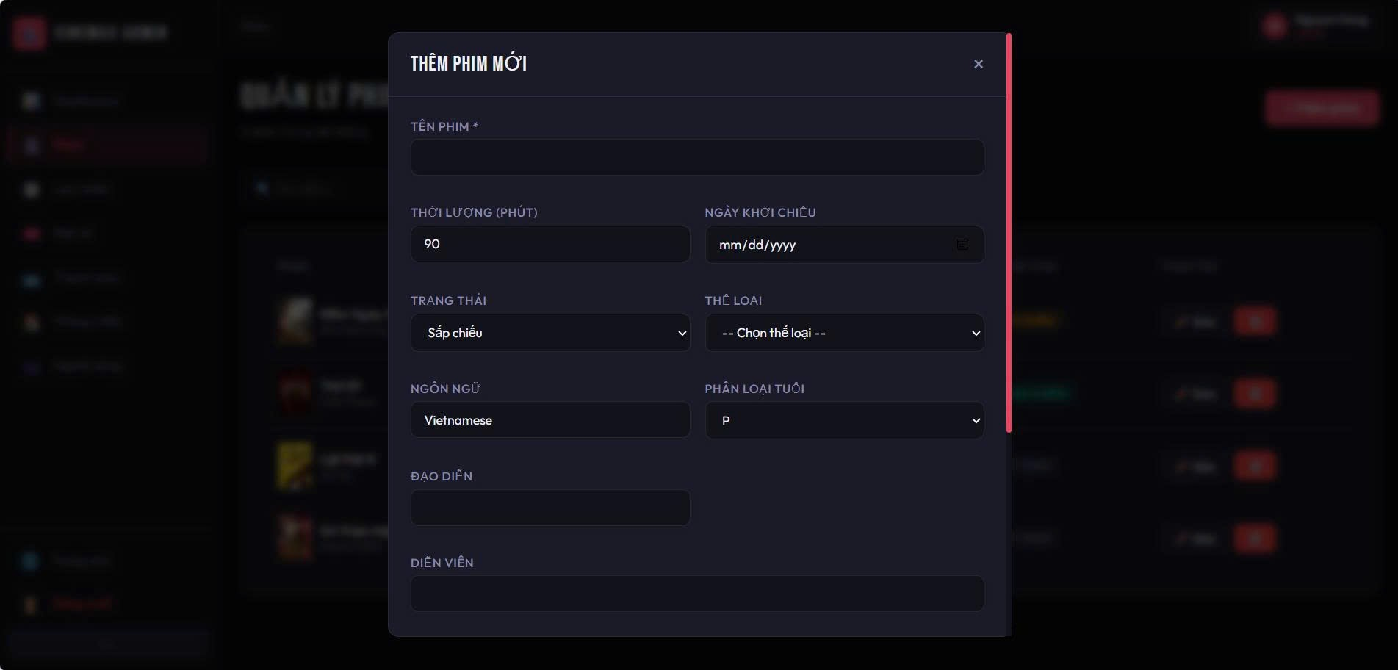

1.10 Add Showtime

- Step 1: The admin navigates to the Showtimes section.
- Step 2: The admin clicks the “Add Showtime” button.
- Step 3: The system displays the showtime creation form.
- Step 4: The admin selects a movie and a screening room.
- Step 5: The admin enters the show date and time.
- Step 6: The admin sets ticket prices (regular, VIP, couple).
- Step 7: The admin submits the form.
- Step 8: The system validates the input data.
- Step 9: The system saves the showtime and updates the schedule list.

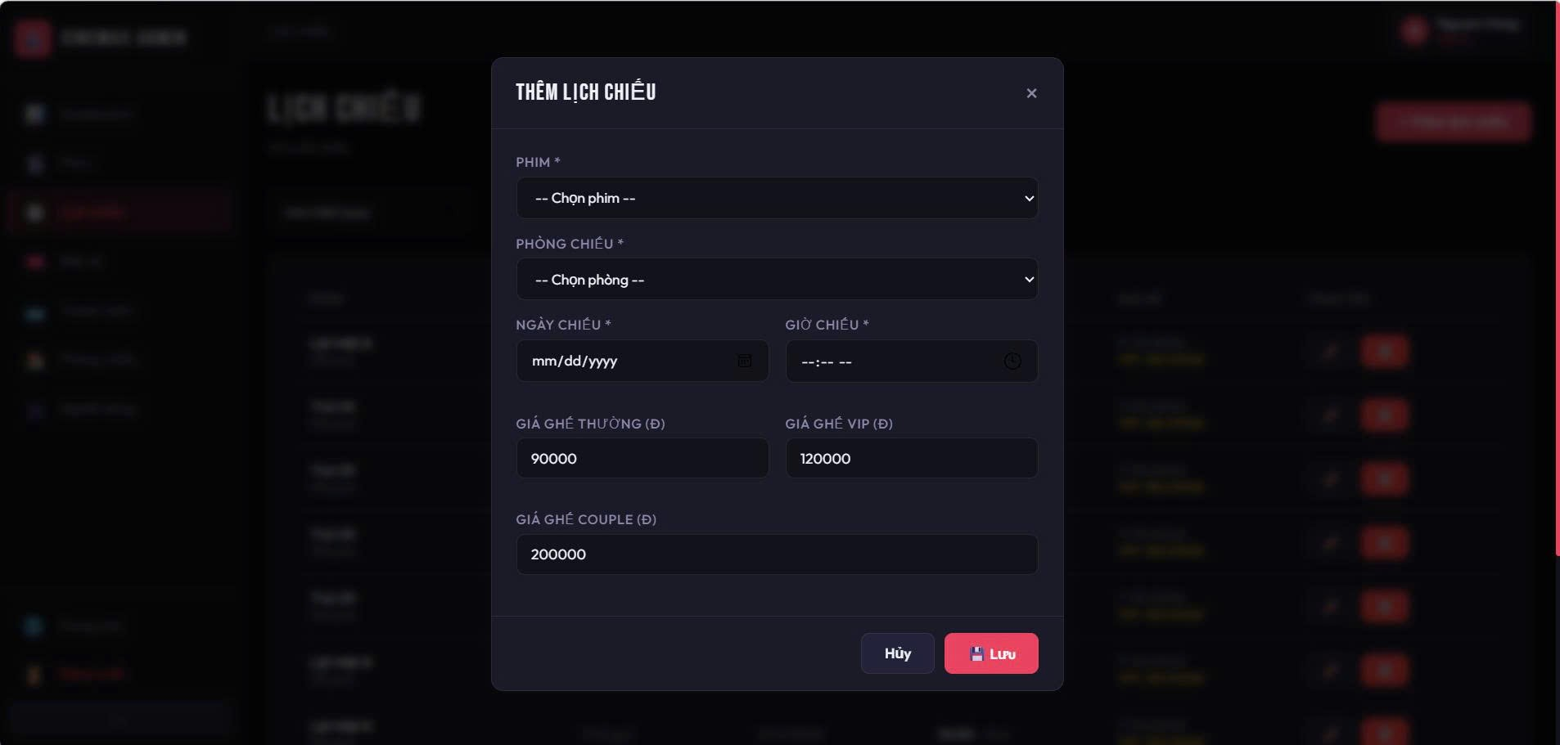

1.11 Management Booking

- Step 1: The admin navigates to the Bookings section.
- Step 2: The system displays a list of all booking orders.
- Step 3: The admin filters bookings by status (All, Pending, Confirmed, Cancelled).
- Step 4: The system updates the booking list based on the selected filter.
- Step 5: The admin views booking details (customer, movie, showtime, seats, total price).
- Step 6: The admin checks the booking status.
- Step 7: The admin performs actions if needed (confirm, cancel, or review booking).
- Step 8: The system updates the booking status in the database.
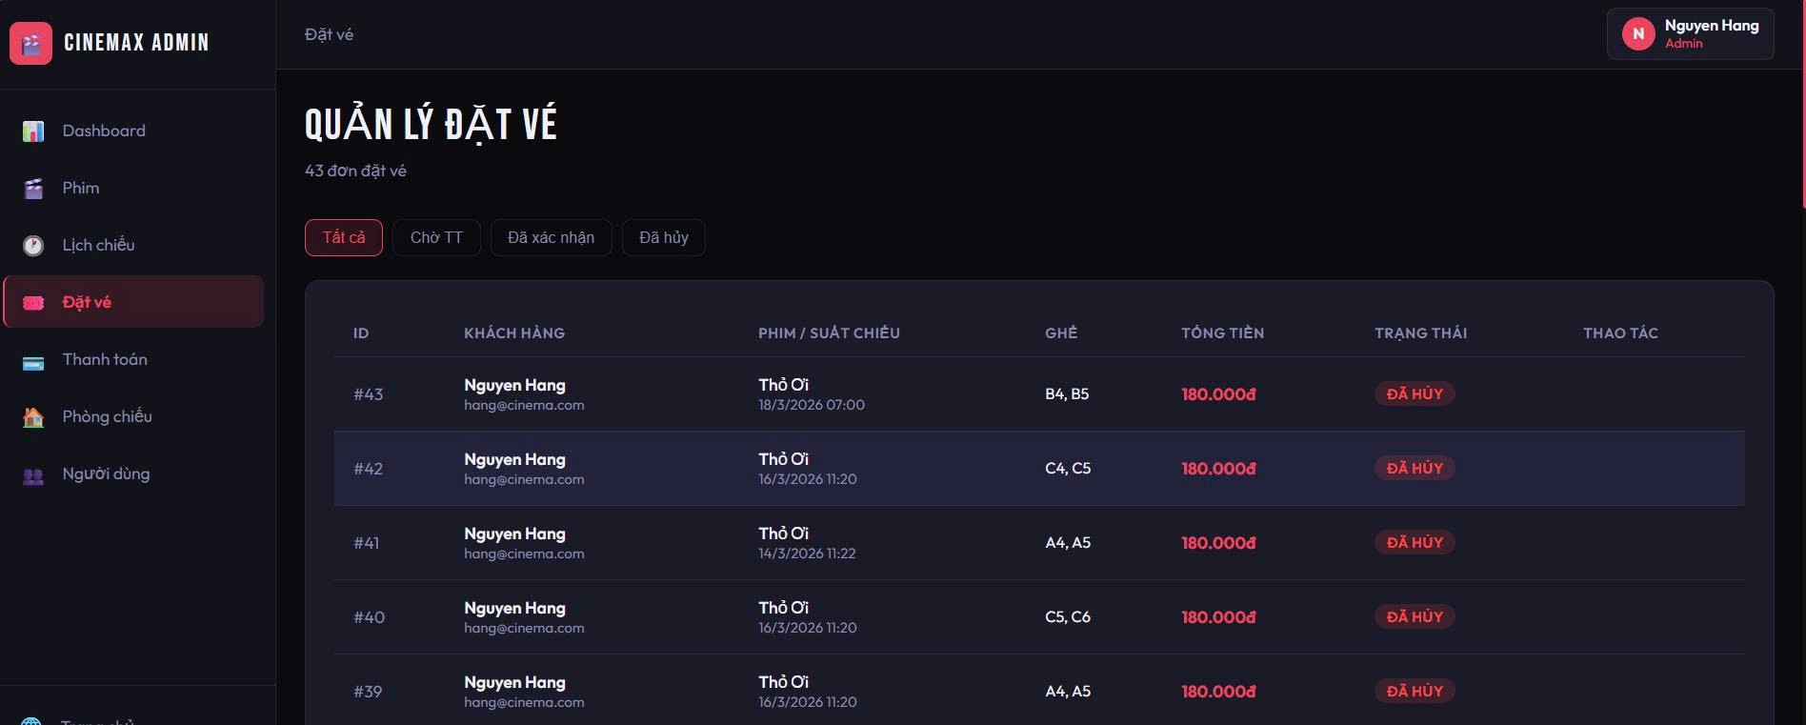

1.12 Management Payment
- Step 1: The admin navigates to the Payments section.
- Step 2: The system displays a list of all transactions.
- Step 3: The admin views summary statistics (total transactions, successful, payment methods).
- Step 4: The admin searches transactions by keyword (transaction ID, customer, movie).
- Step 5: The system filters and updates the transaction list.
Step 6: The admin views transaction details (customer, movie, amount, payment method, status, time).
- Step 7: The admin verifies the payment status (e.g., successful).
- Step 8: The system stores and maintains transaction records in the database.

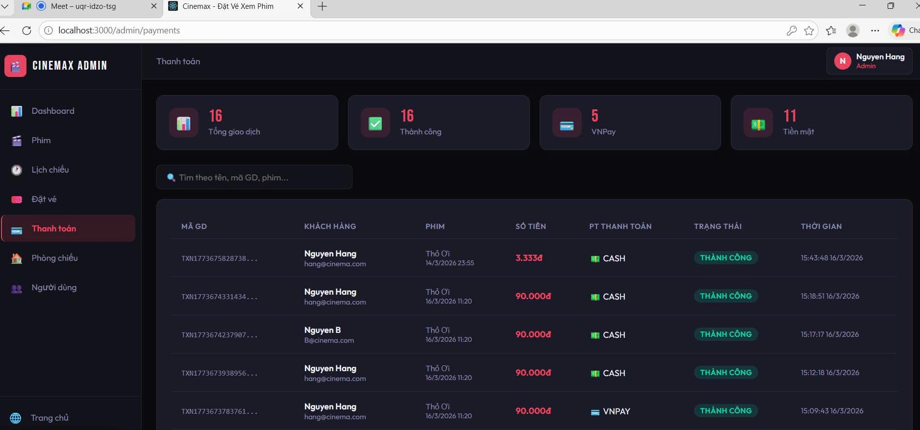

1.13 Management User

- Step 1: The admin navigates to the Users section.
- Step 2: The system displays a list of all users.
- Step 3: The admin searches users by name or email.
- Step 4: The admin filters users by role (Admin, Manager, Staff, Customer).
- Step 5: The system updates the user list based on search/filter conditions.
- Step 6: The admin views user details (name, contact, role, status, created date).
- Step 7: The admin edits user information if needed.
- Step 8: The admin can activate or deactivate (lock) a user account.
- Step 9: The system updates user data in the database.
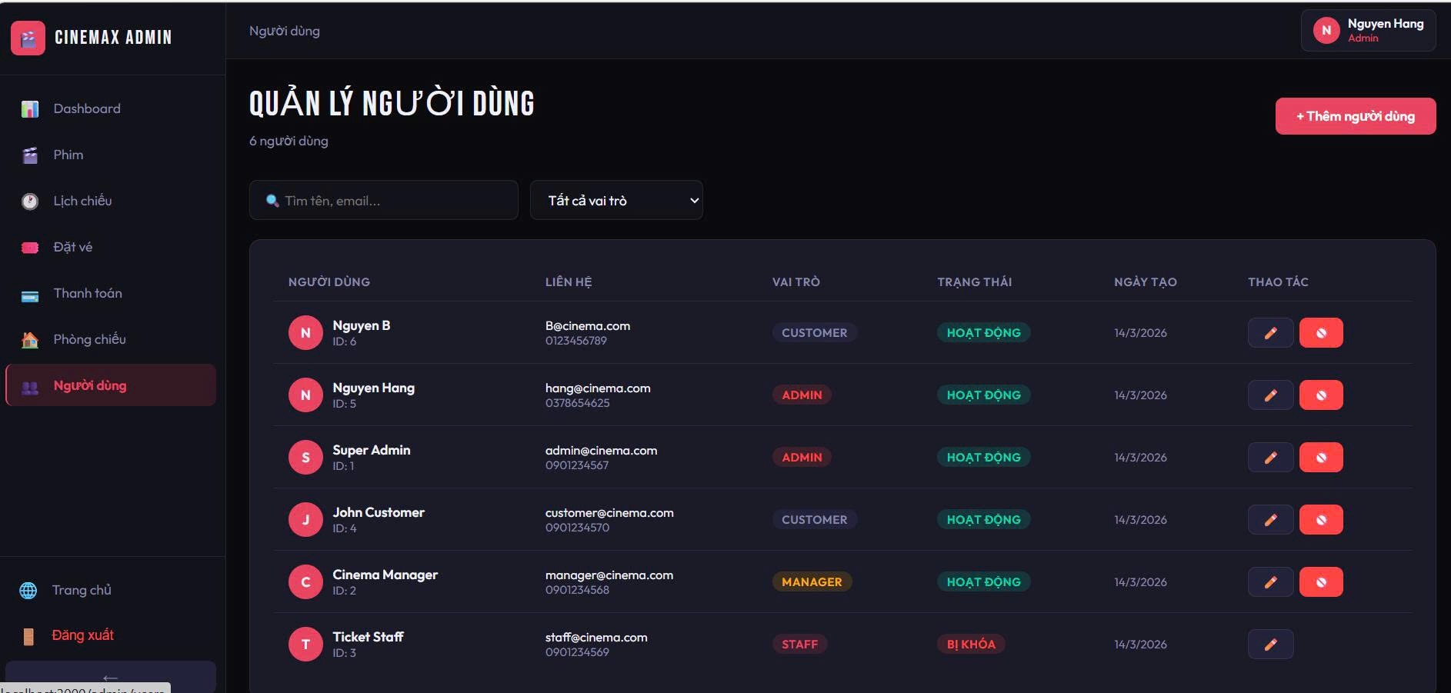

1.14 Add Room
- Step 1: The admin navigates to the Rooms section.
- Step 2: The admin clicks the “Add Room” button.
- Step 3: The system displays the room creation form.
- Step 4: The admin enters the room name.
- Step 5: The admin selects the room status (active/inactive).
- Step 6: The admin configures seat layout (rows, columns).
- Step 7: The admin defines VIP seat rows if needed.
- Step 8: The admin submits the form.
- Step 9: The system validates and saves the room configuration.
- Step 10: The system generates seats automatically and updates the room list.

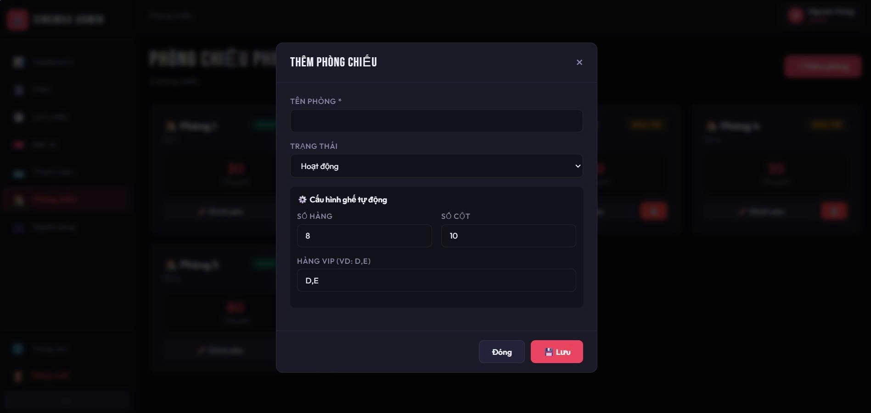

1.15 Ticket
- Step 1: The user completes the booking process.
- Step 2: The user selects a payment method (e.g., cash, VNPAY).
- Step 3: The user confirms the payment.
- Step 4: The system processes the transaction.
- Step 5: The system displays the payment result (success/failure).
- Step 6: If successful, the system generates an e-ticket.
- Step 7: The system displays payment details (transaction ID, time, status).
- Step 8: The system generates a QR code for the ticket.
- Step 9: The user can use the QR code for check-in at the cinema.

